Linval Bailey

4/9/2023

Task 1

3.1 Resource Group Creation (slides 18-19)

3.1.1 Create a resource group

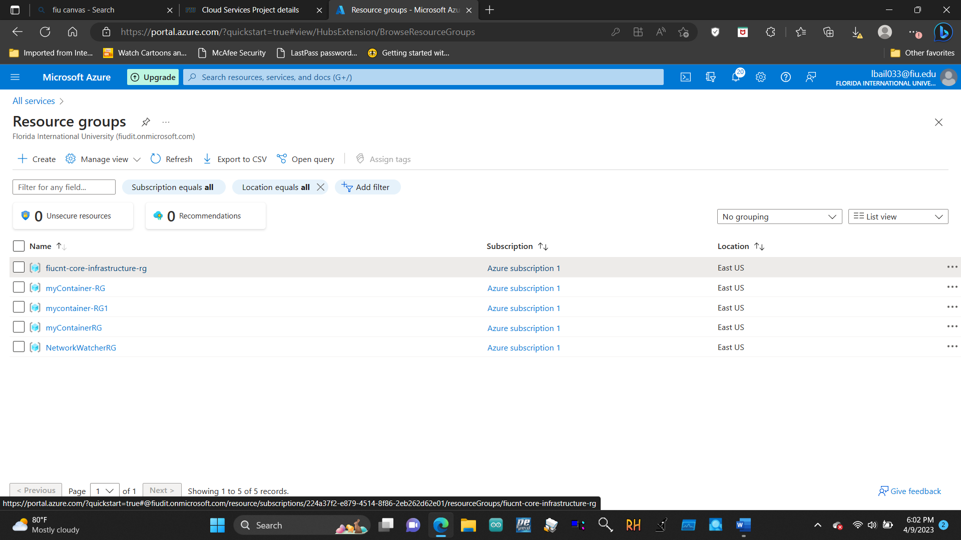

3.1.2 Create a resource inside a resource group 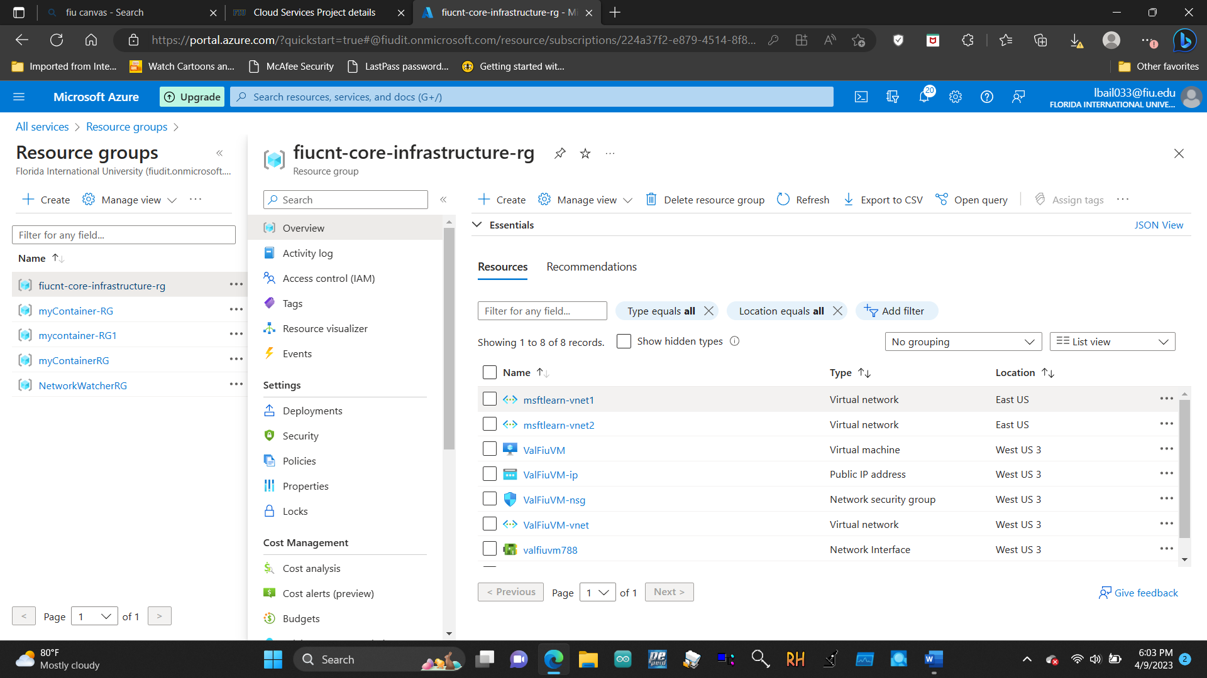

3.2 Creating Virtual Machine & Making Web Server (slides 24-27)

3.2.1 Create the virtual machine

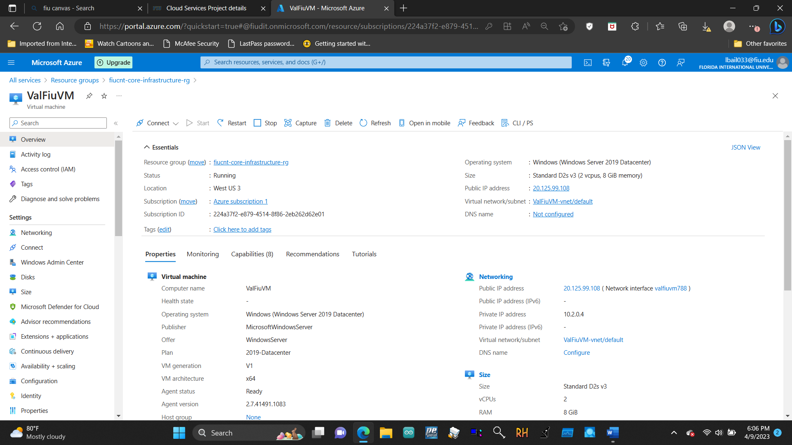

3.2.2 Connect to the virtual machine

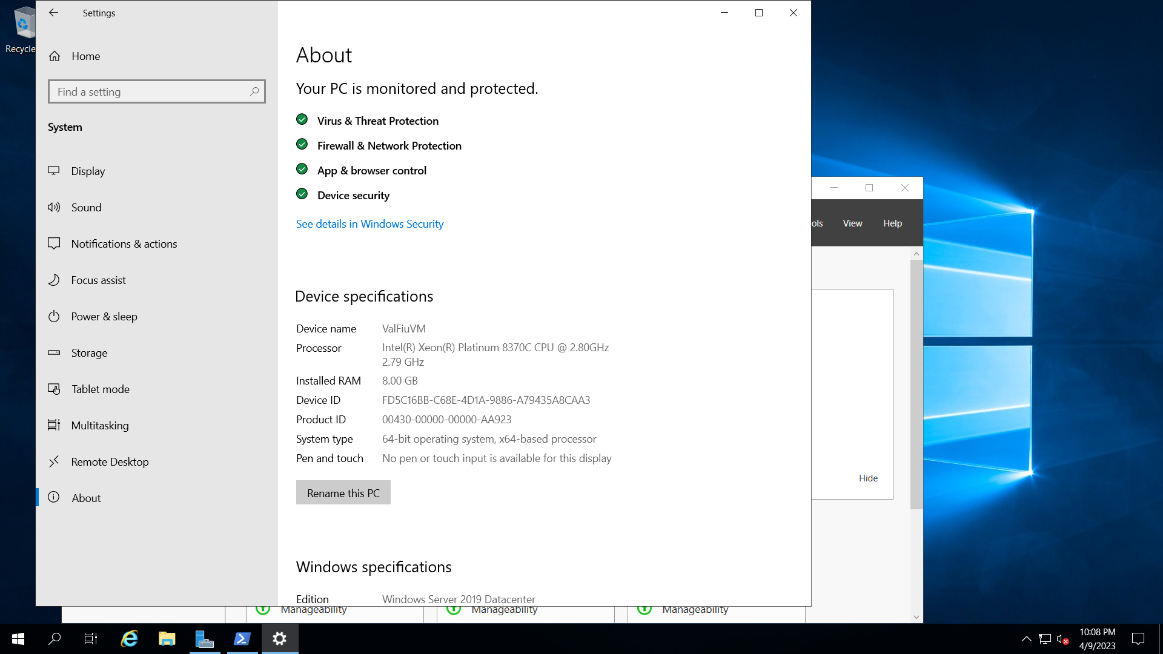

3.2.3 Install the web server role and test

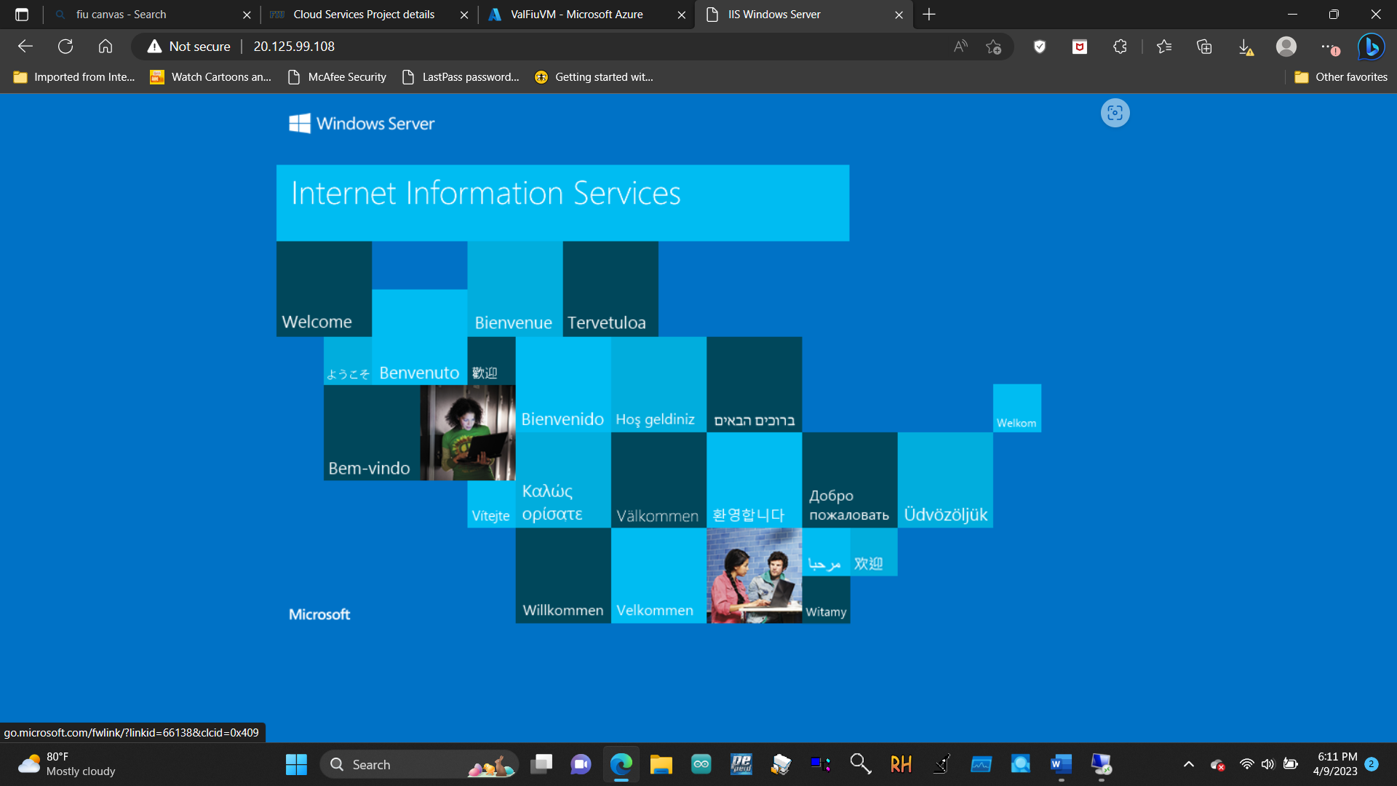

3.3 Deploy Azure Container Instances (slides 33-35)

3.3.1 Create a container instance

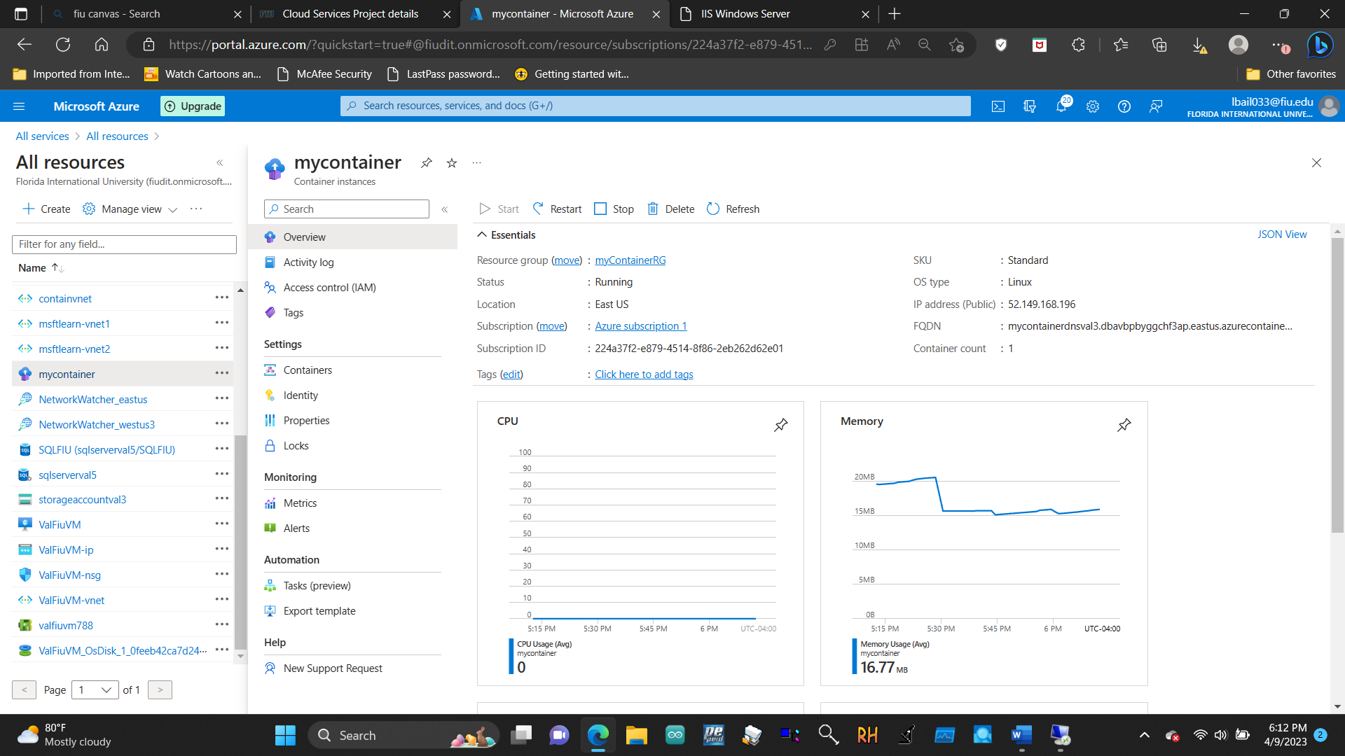

3.3.2 Verify deployment of the container instance

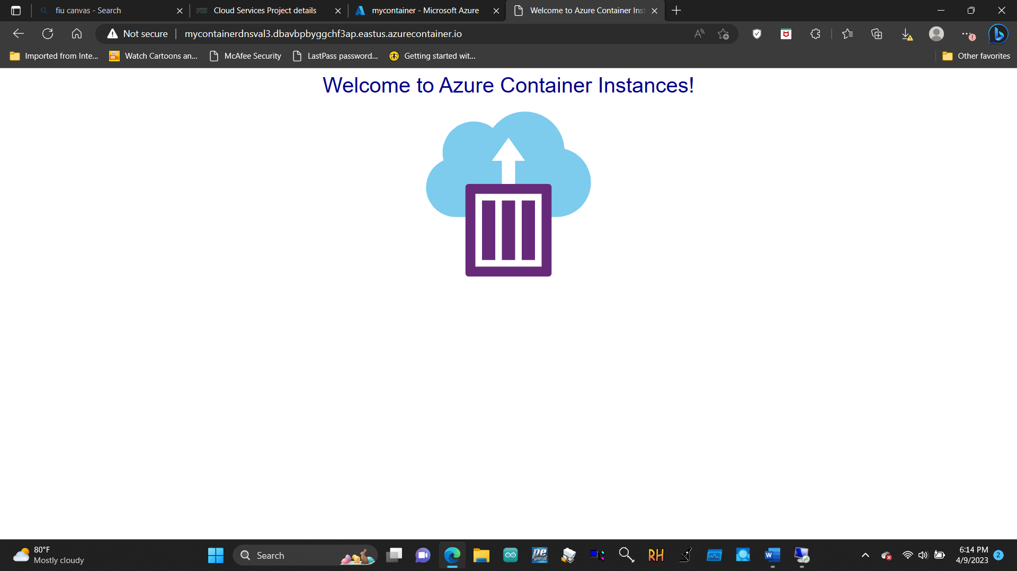

3.4 Create a virtual network (slides 37-40)

3.4.1 Create a virtual network

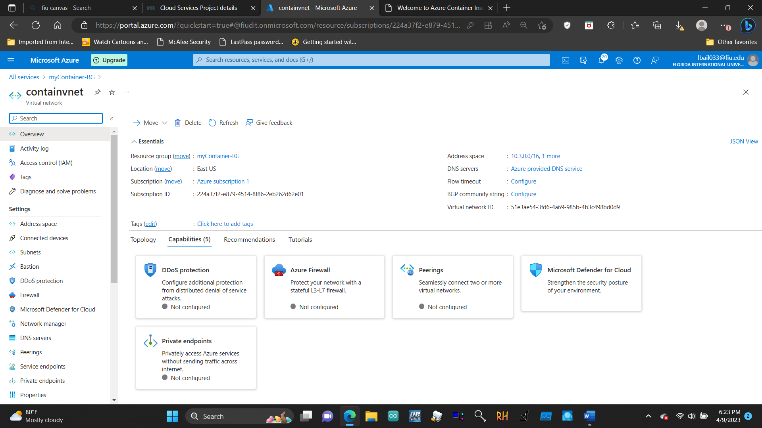

3.4.2 Create two virtual machines

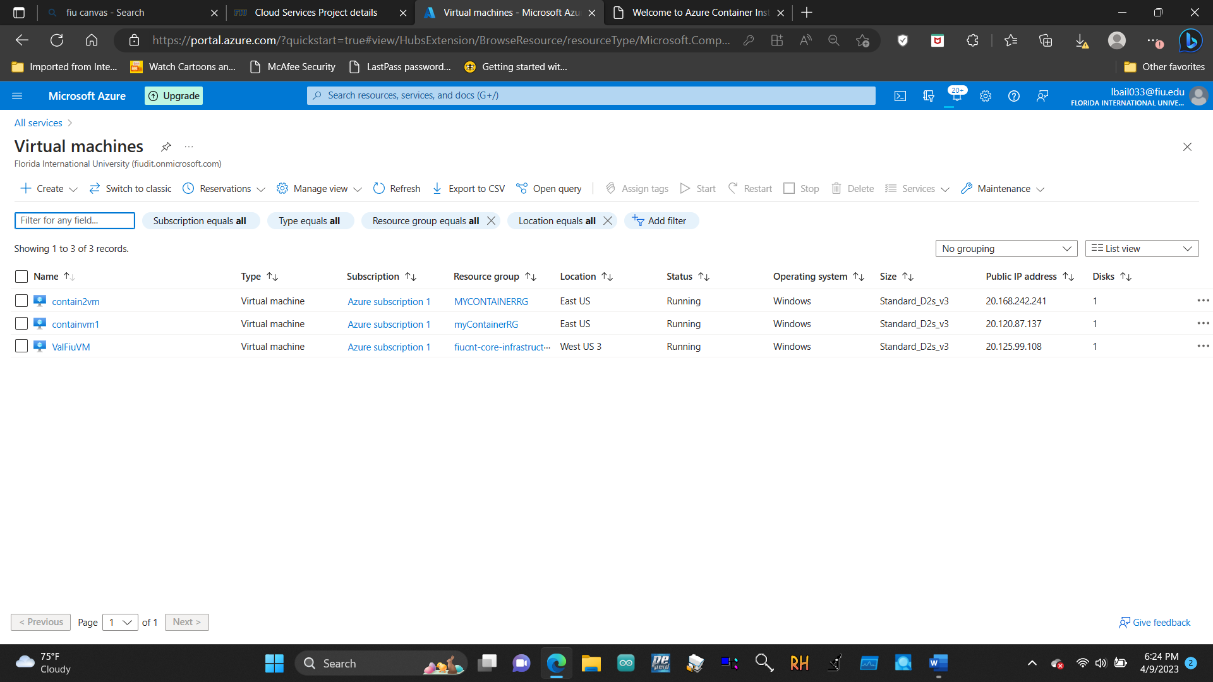

3.4.3 Test the connection

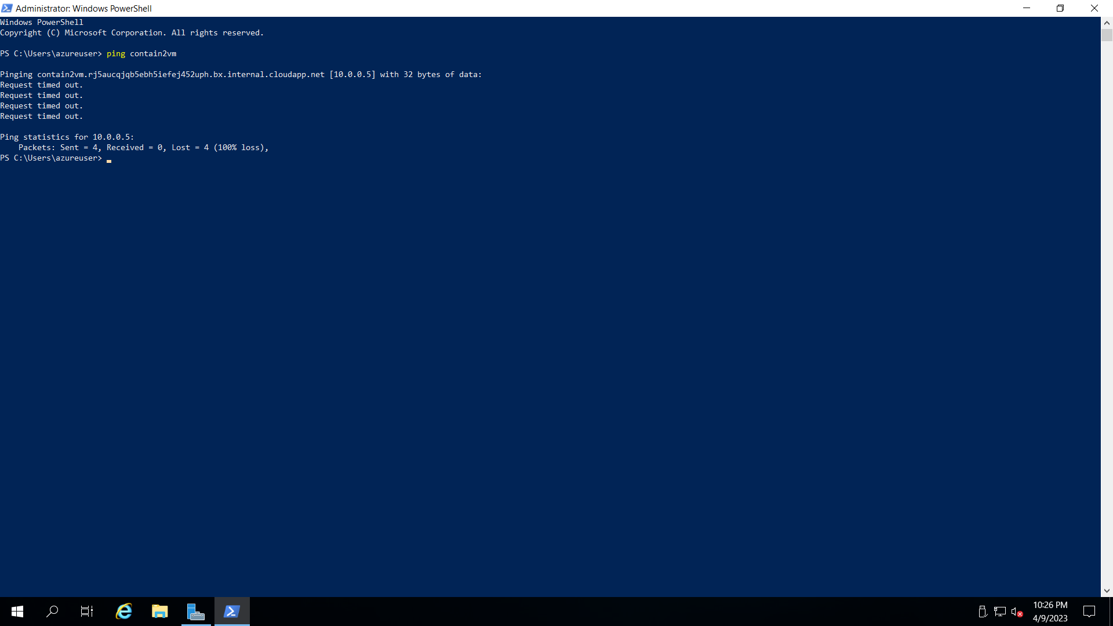

3.5 Create Blob Storage (slides 45-48)

3.5.1 Create a storage account

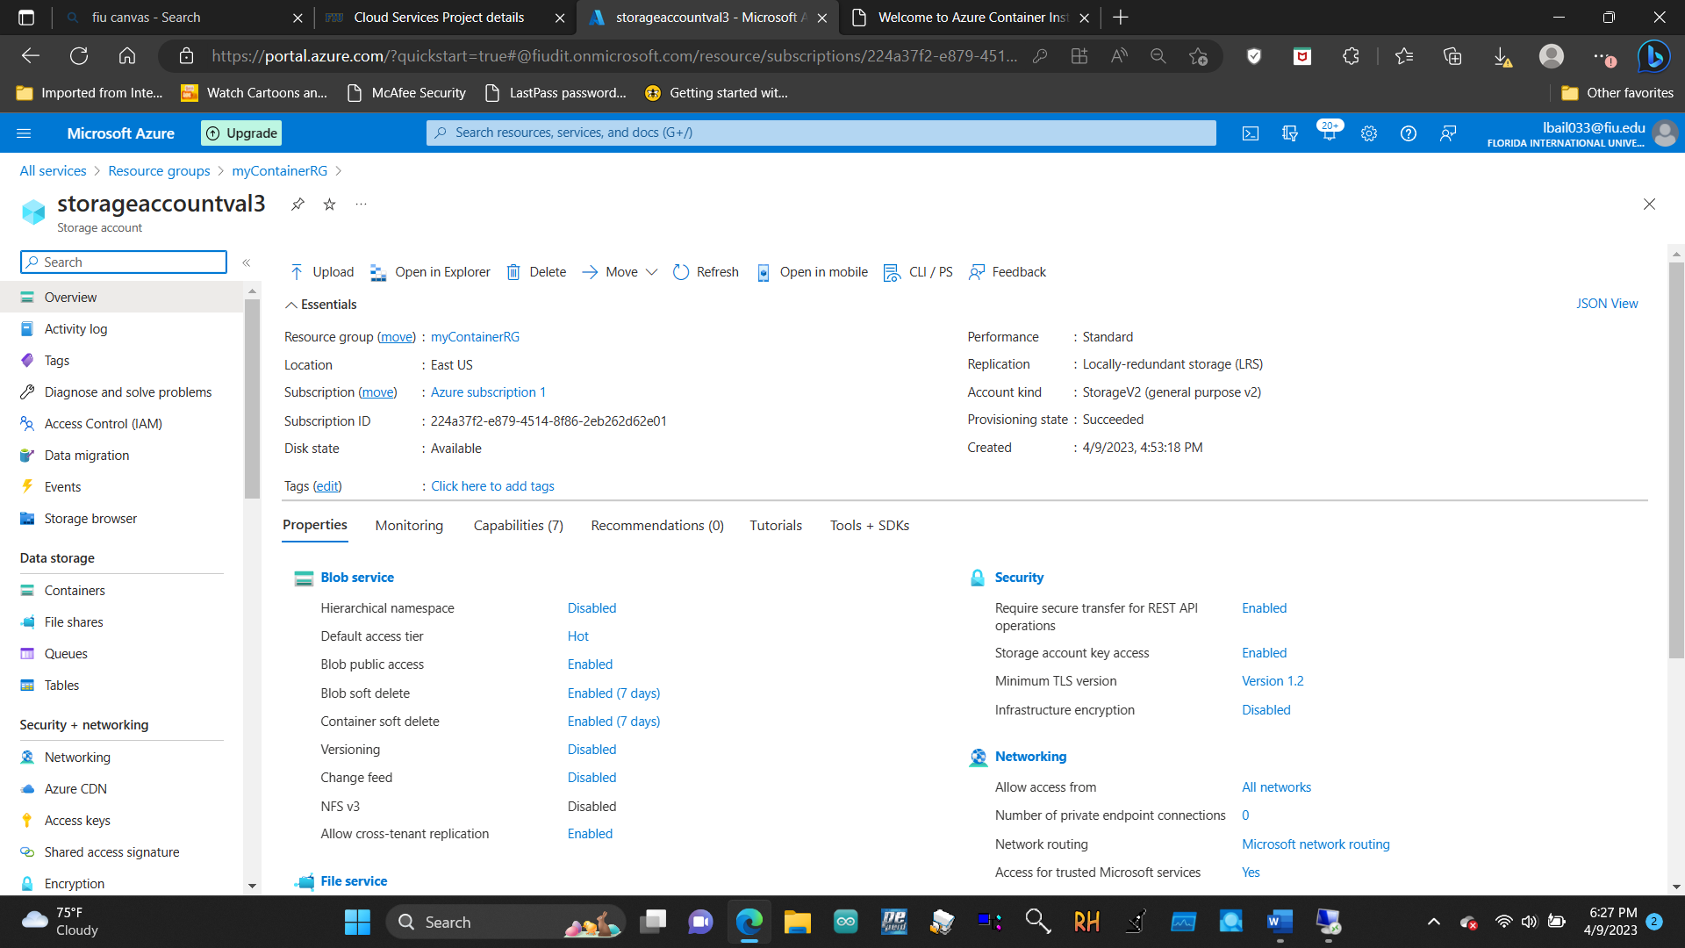

3.5.2 Work with blob storage

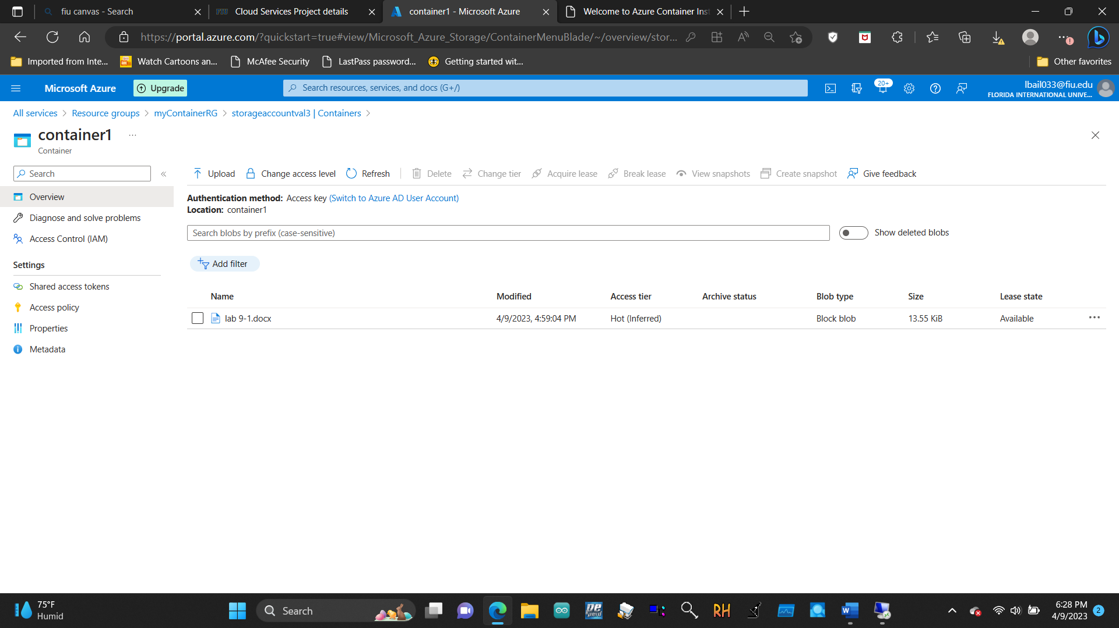

3.6 Create a SQL database (slides 50-52)

3.6.1 Create the database

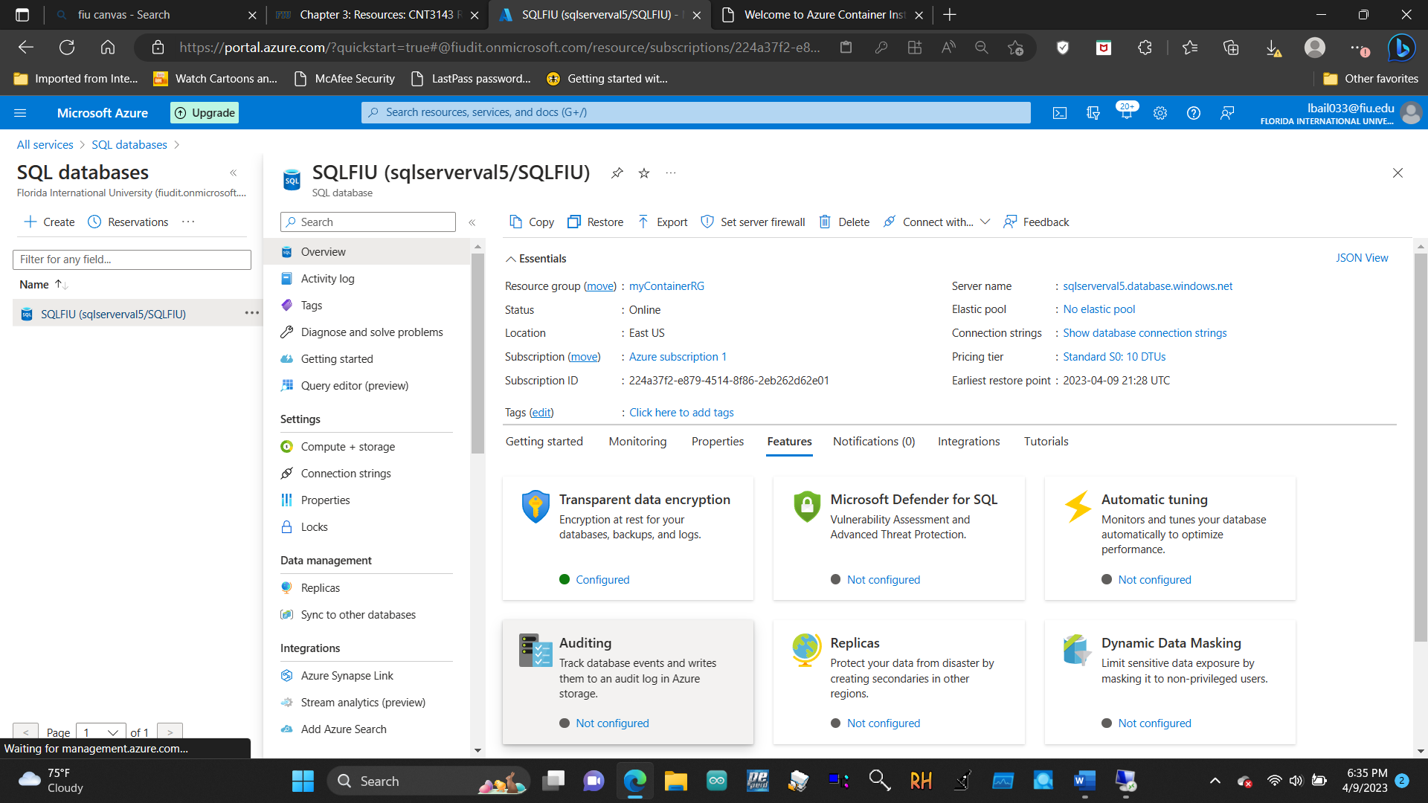

3.6.2 Test the database

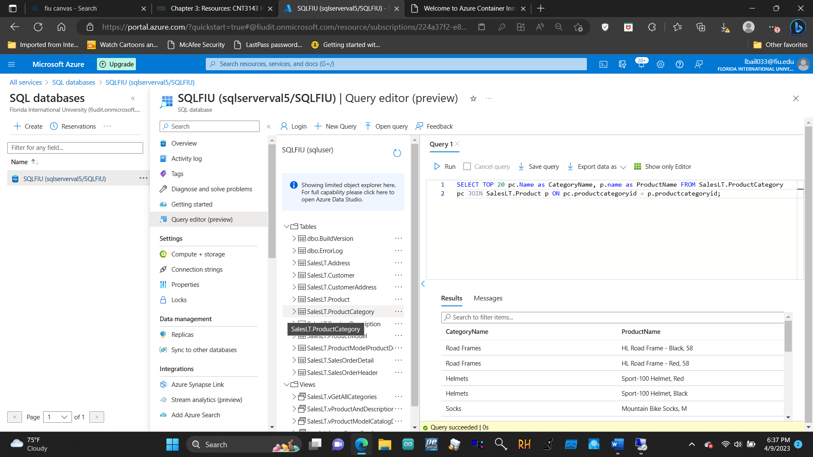

4.1 Implement the Azure IoT Hub (slides 5-8) 4.1.1 Create an IoT Hub

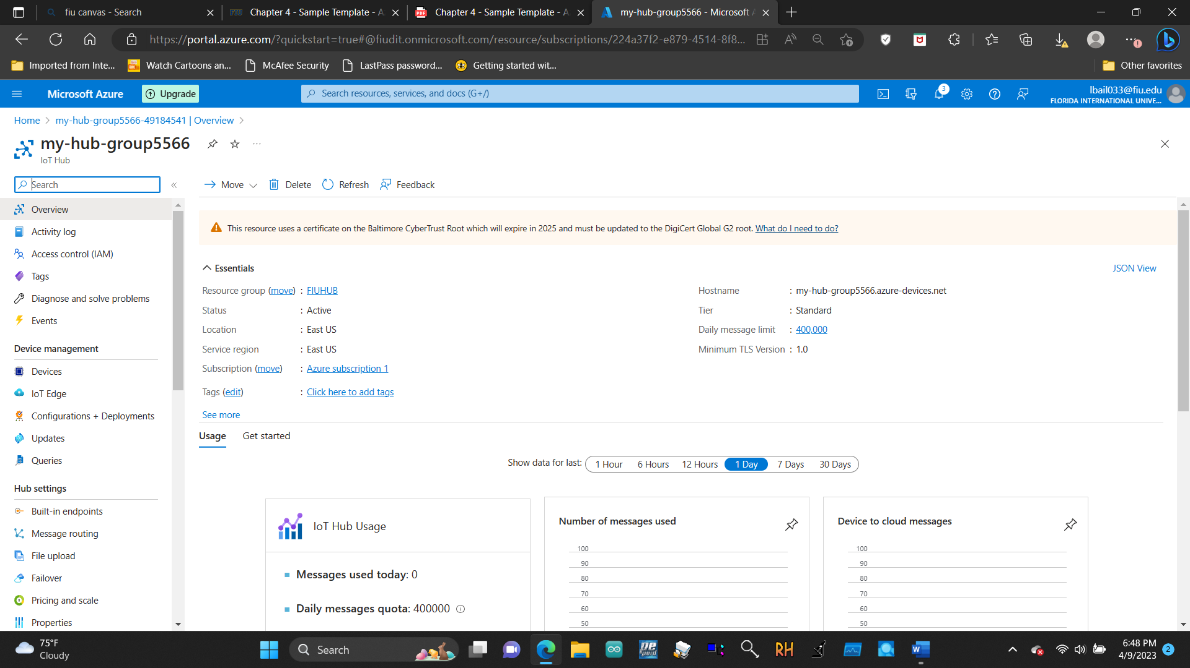

4.1.2 Add an IoT device

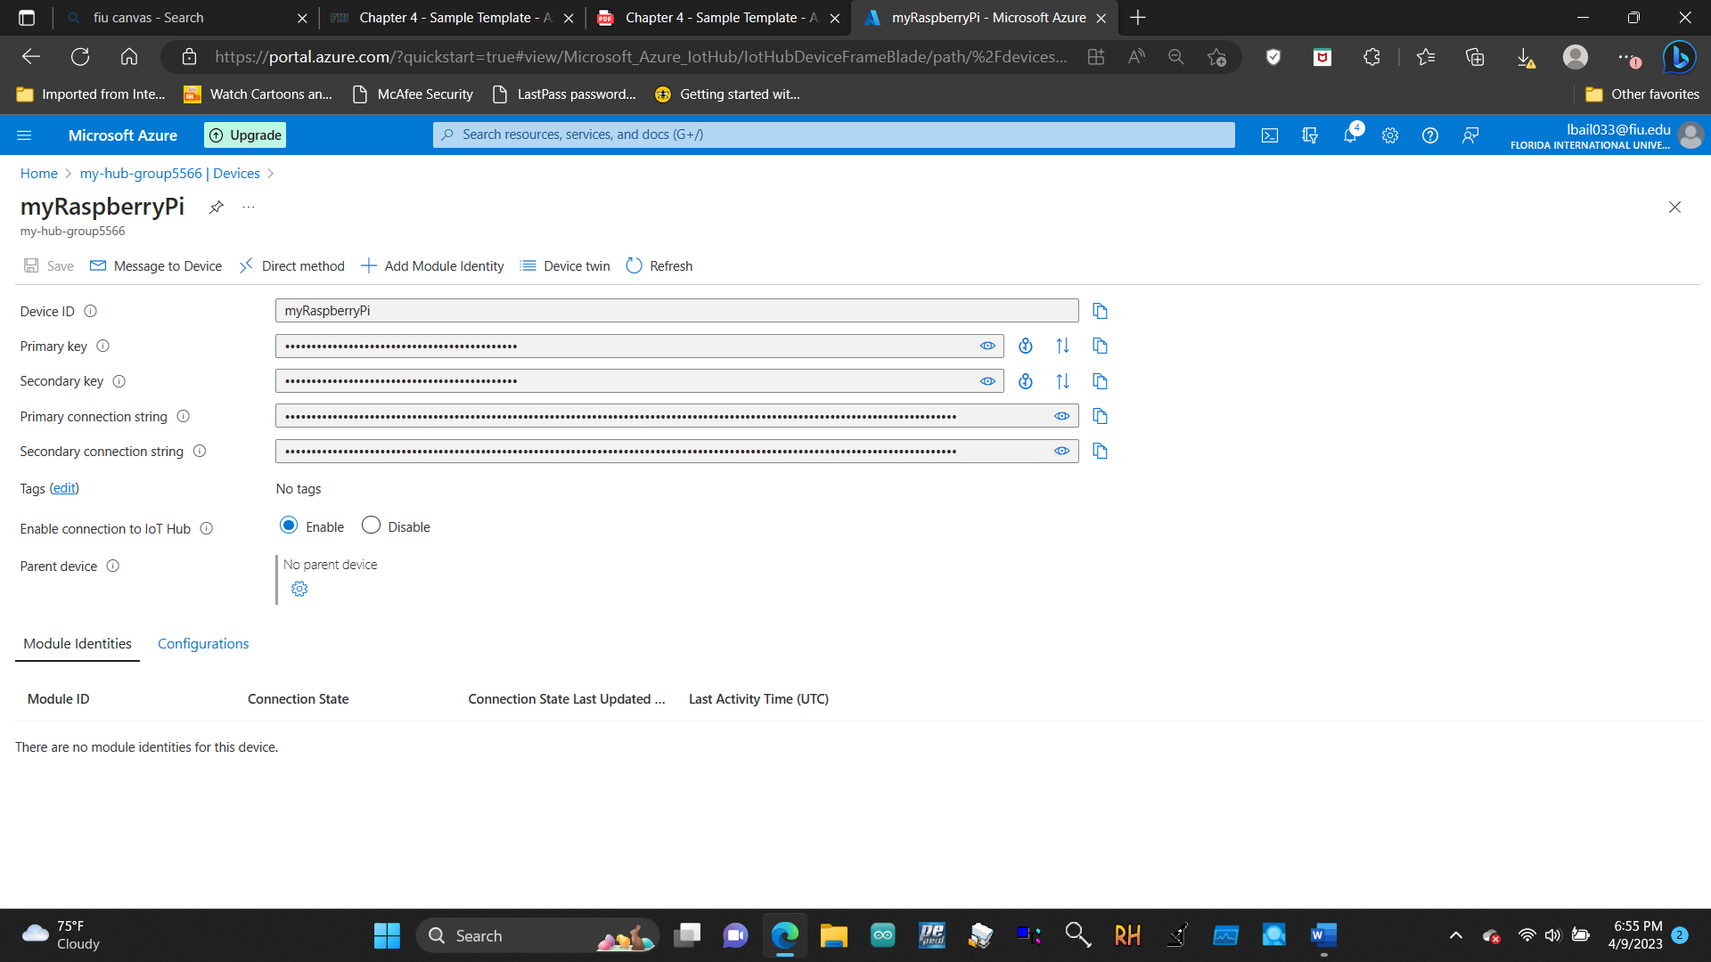

4.1.3 Test the device using the Raspberry Pi Simulator

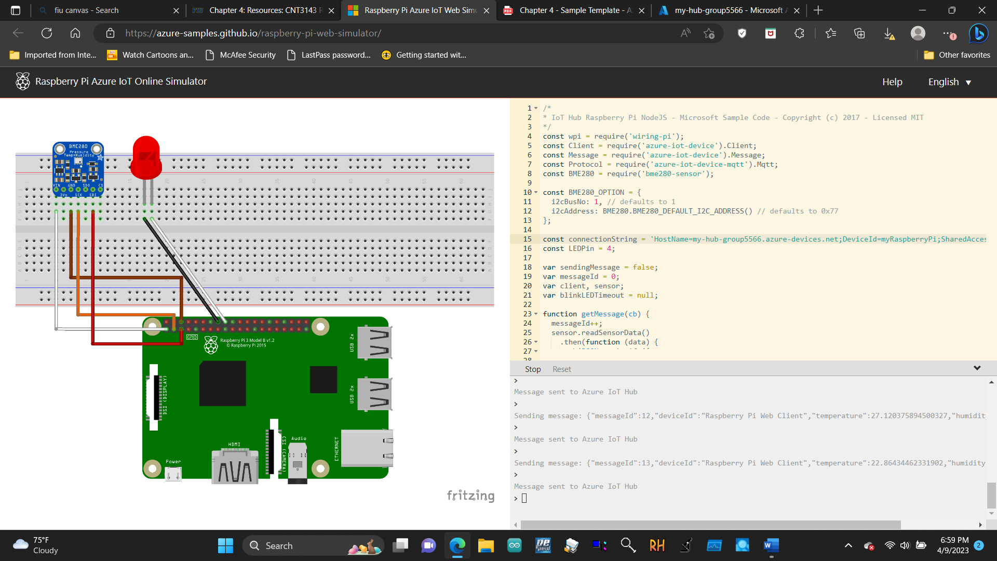

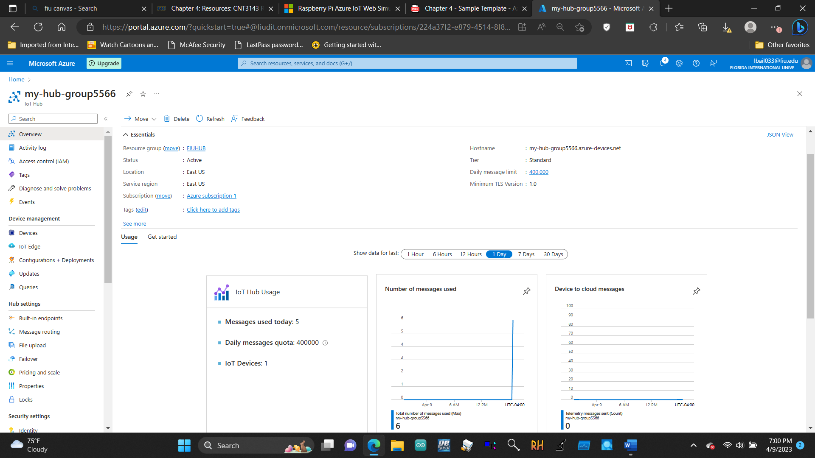

4.2 Implement Azure Functions (slides 14-16) 4.2.1 Create a Function app

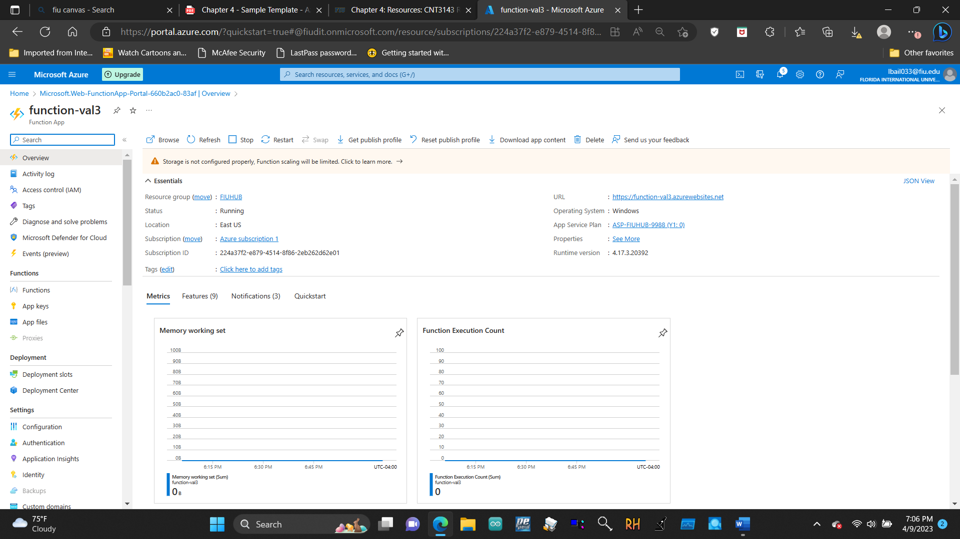

4.2.2 Create a HTTP triggered event function and test

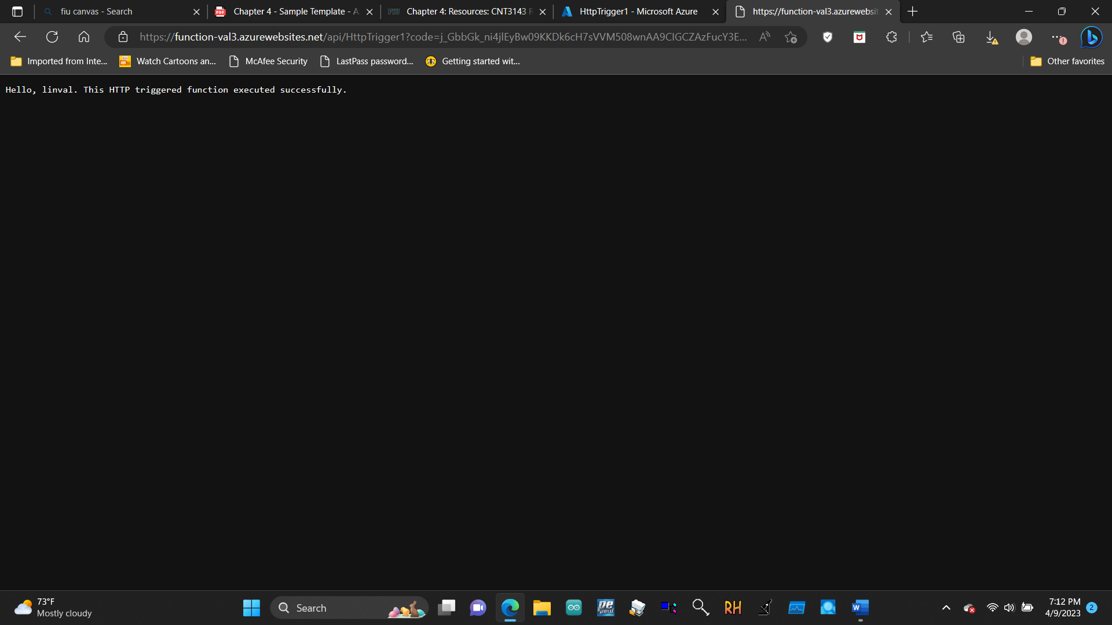

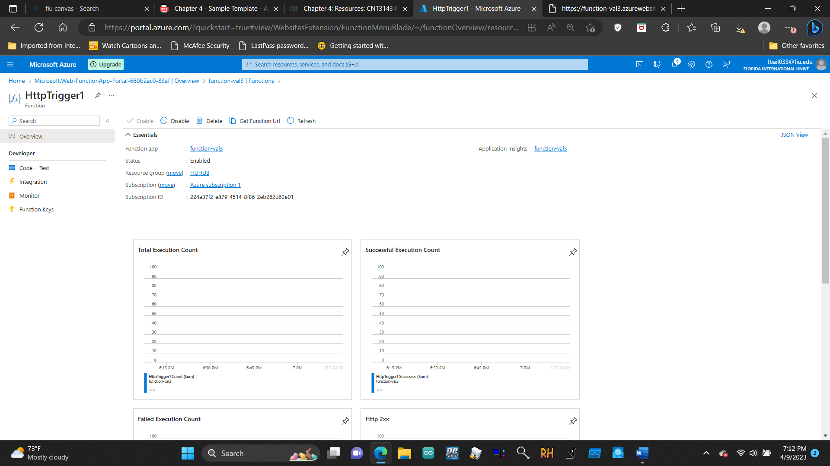

4.3 Create a Web App (slides 19-21) 4.3.1 Create a Web App

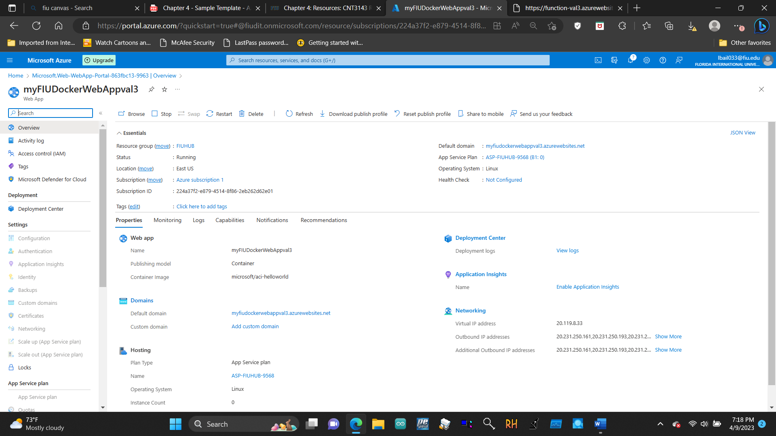

4.4 Create a VM with an ARM Template (slides 24-26) 4.4.1 Explore the gallery and locate a template

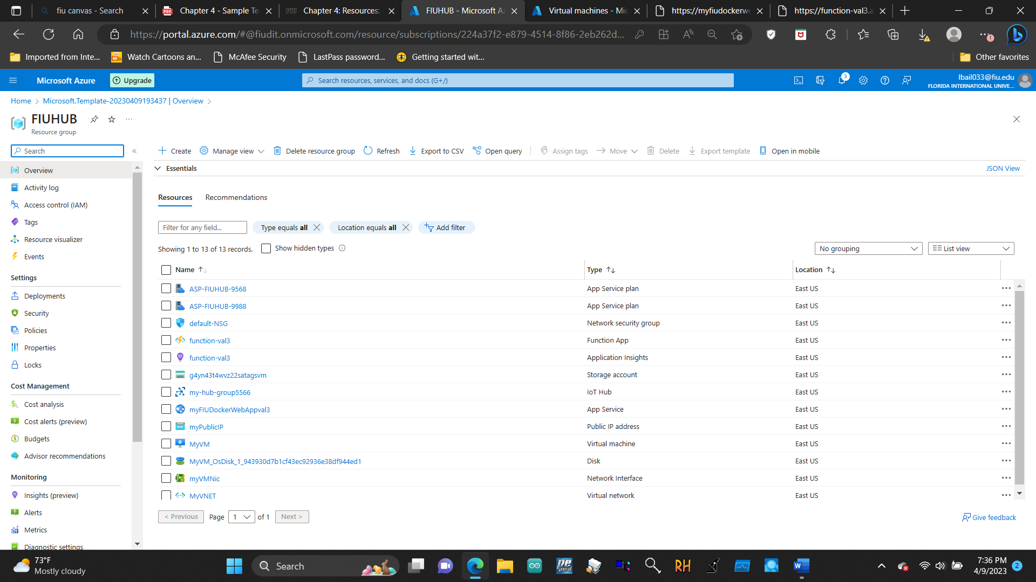

4.4.2 Verify and monitor your virtual machine deployment

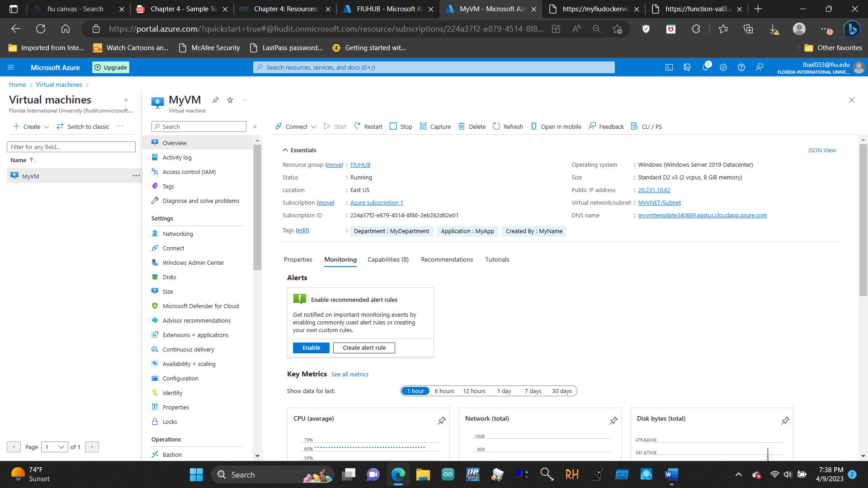

4.5 Create a VM with PowerShell (slides 27-30) 4.5.1 Configure PowerShell locally

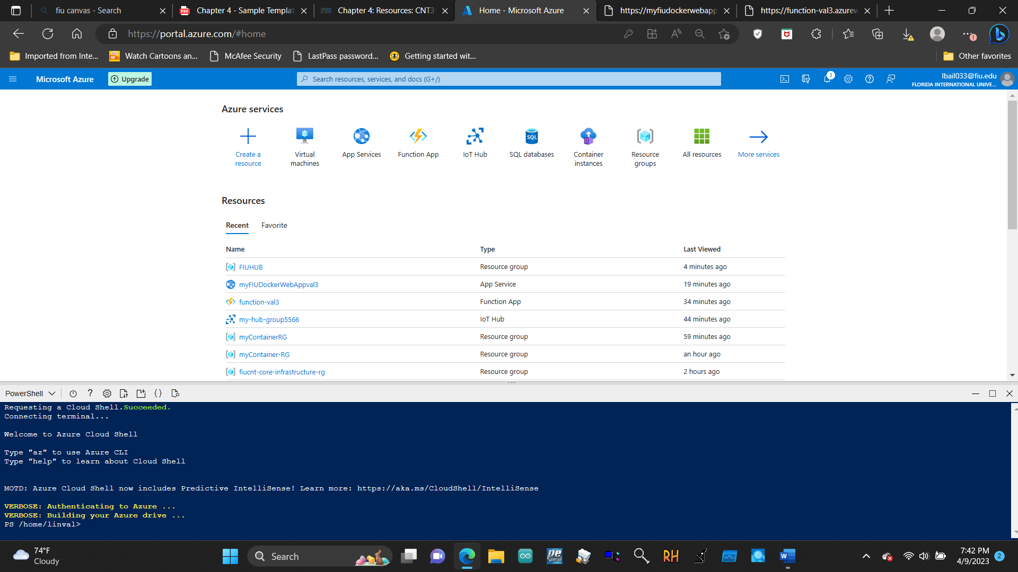

4.5.2 Verify resource group and Create virtual machine

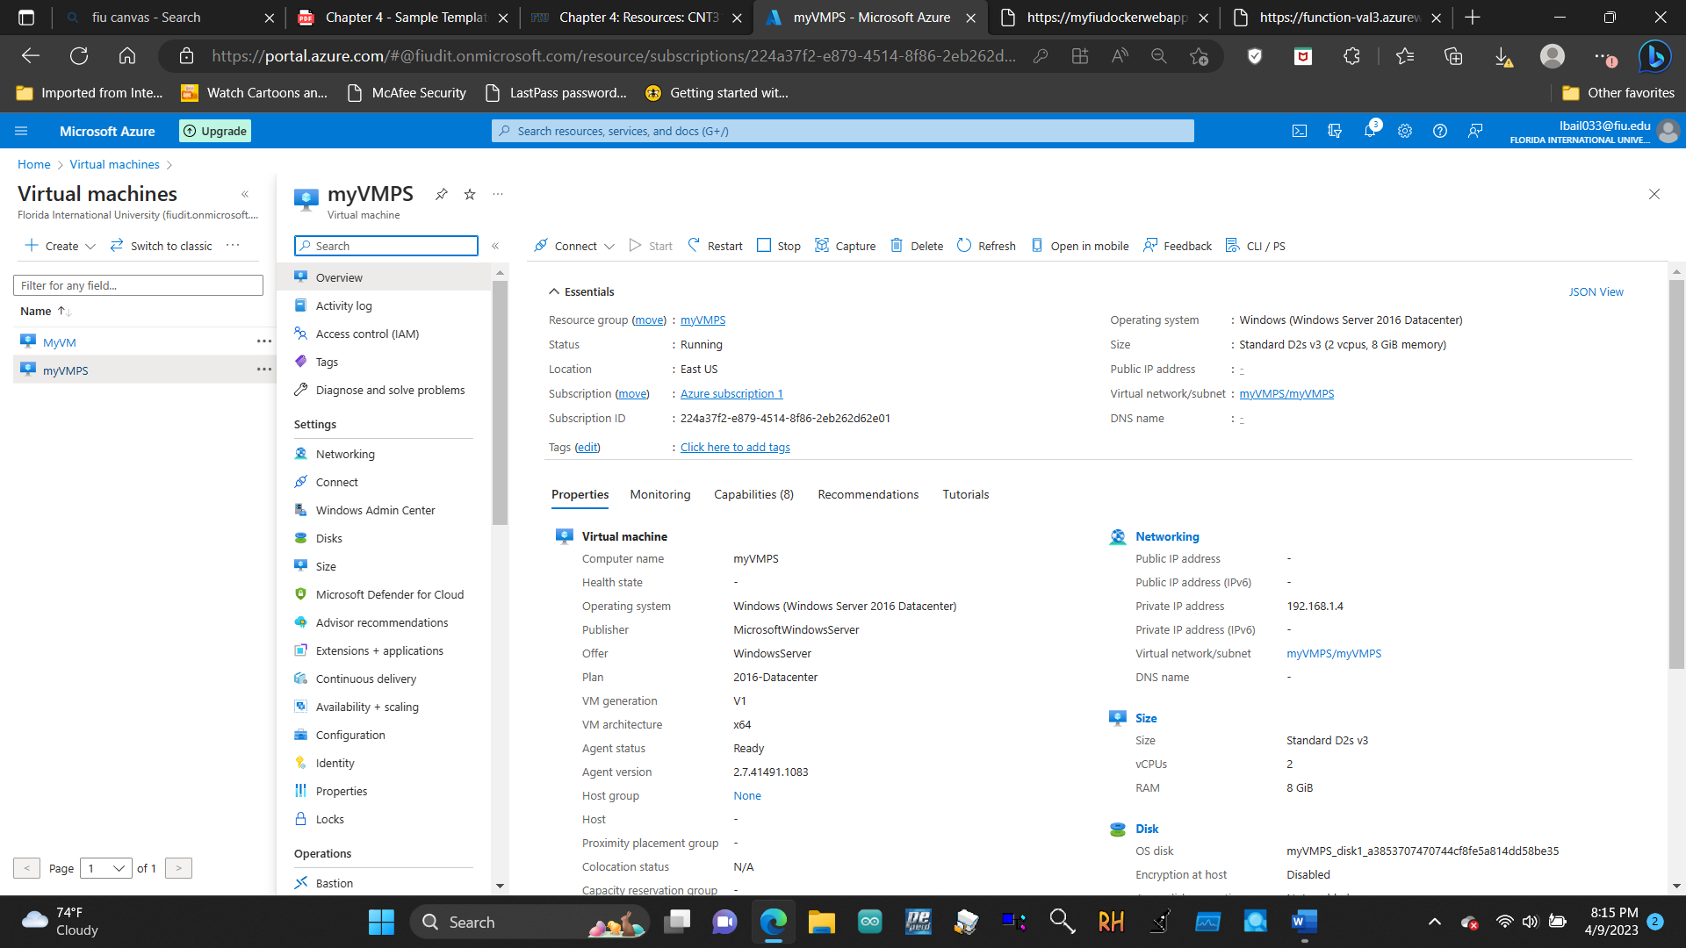

4.5.3 Execute commands in the Cloud Shell

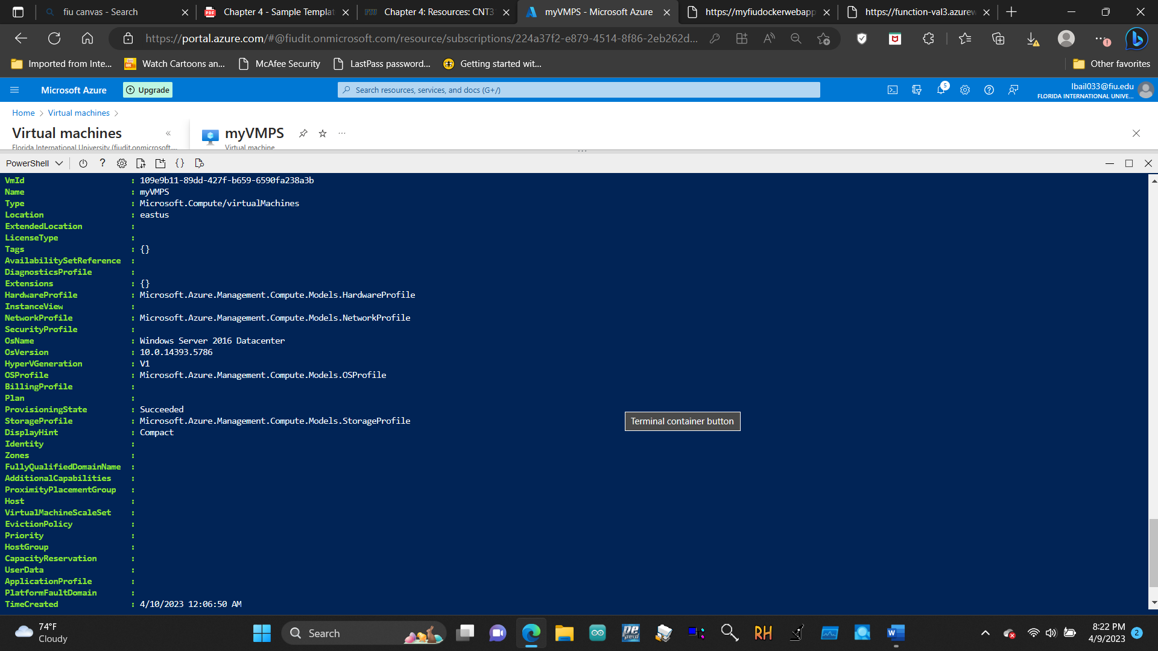

4.6 Create a VM with the Azure CLI (slides 31-35) 4.5.1 Configure the Cloud Shell

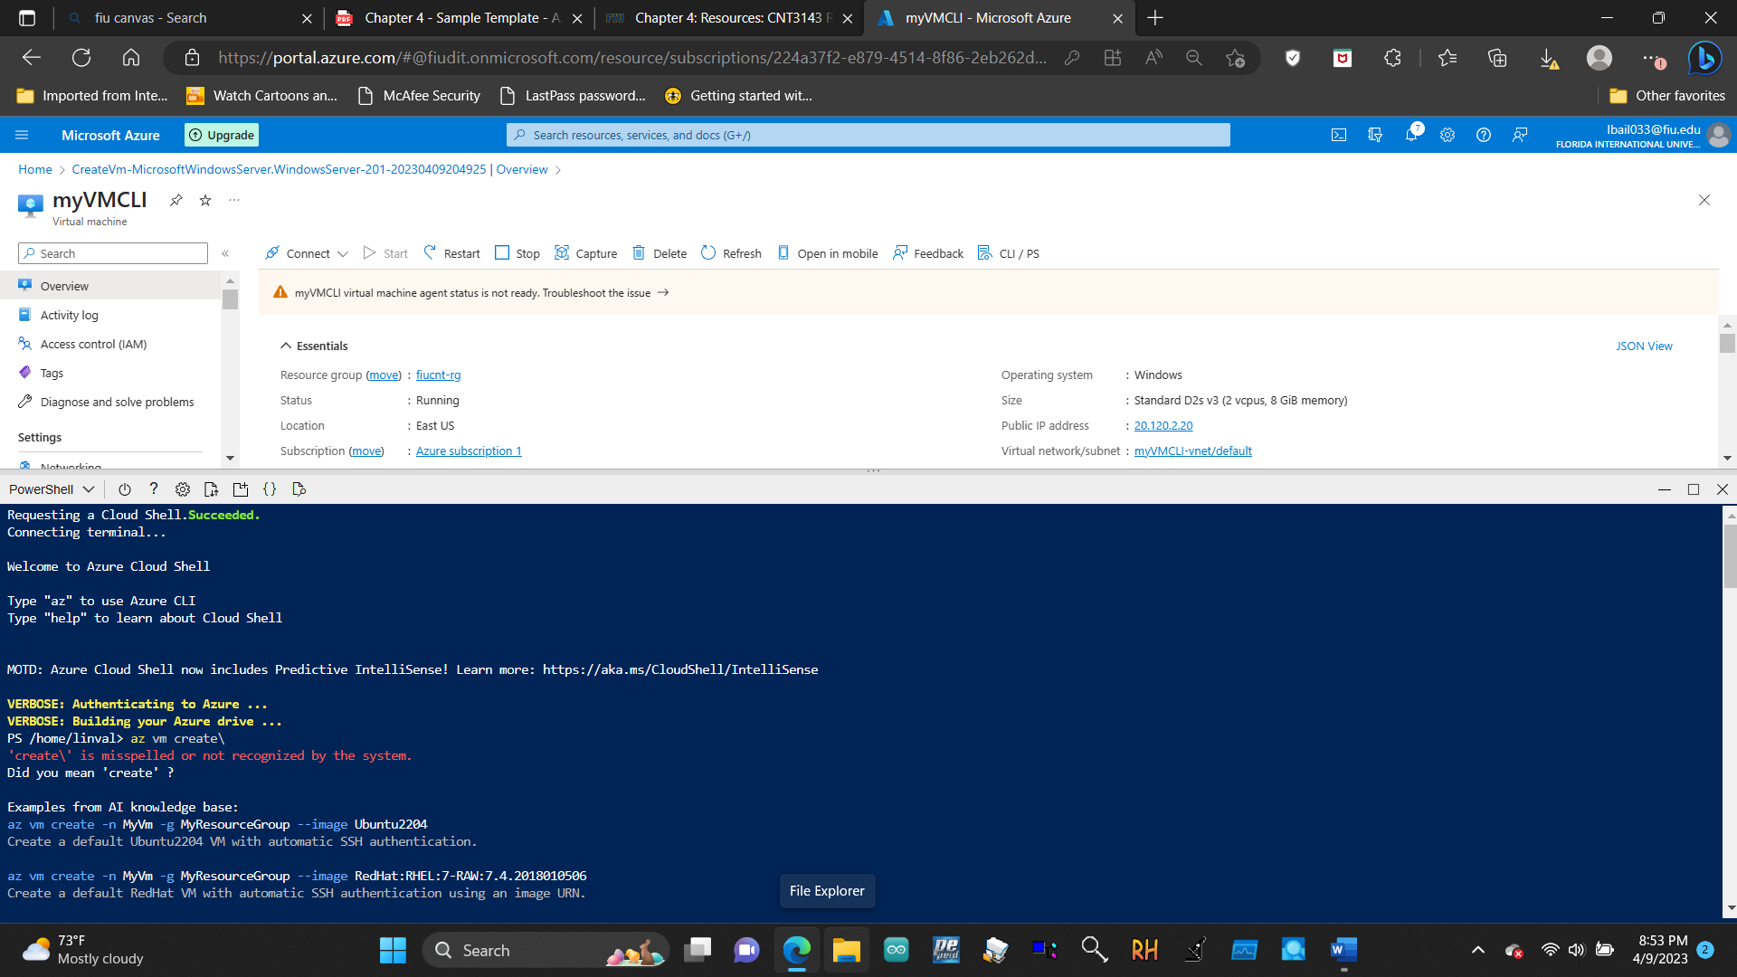

4.5.2 Verify resource group and Create virtual machine

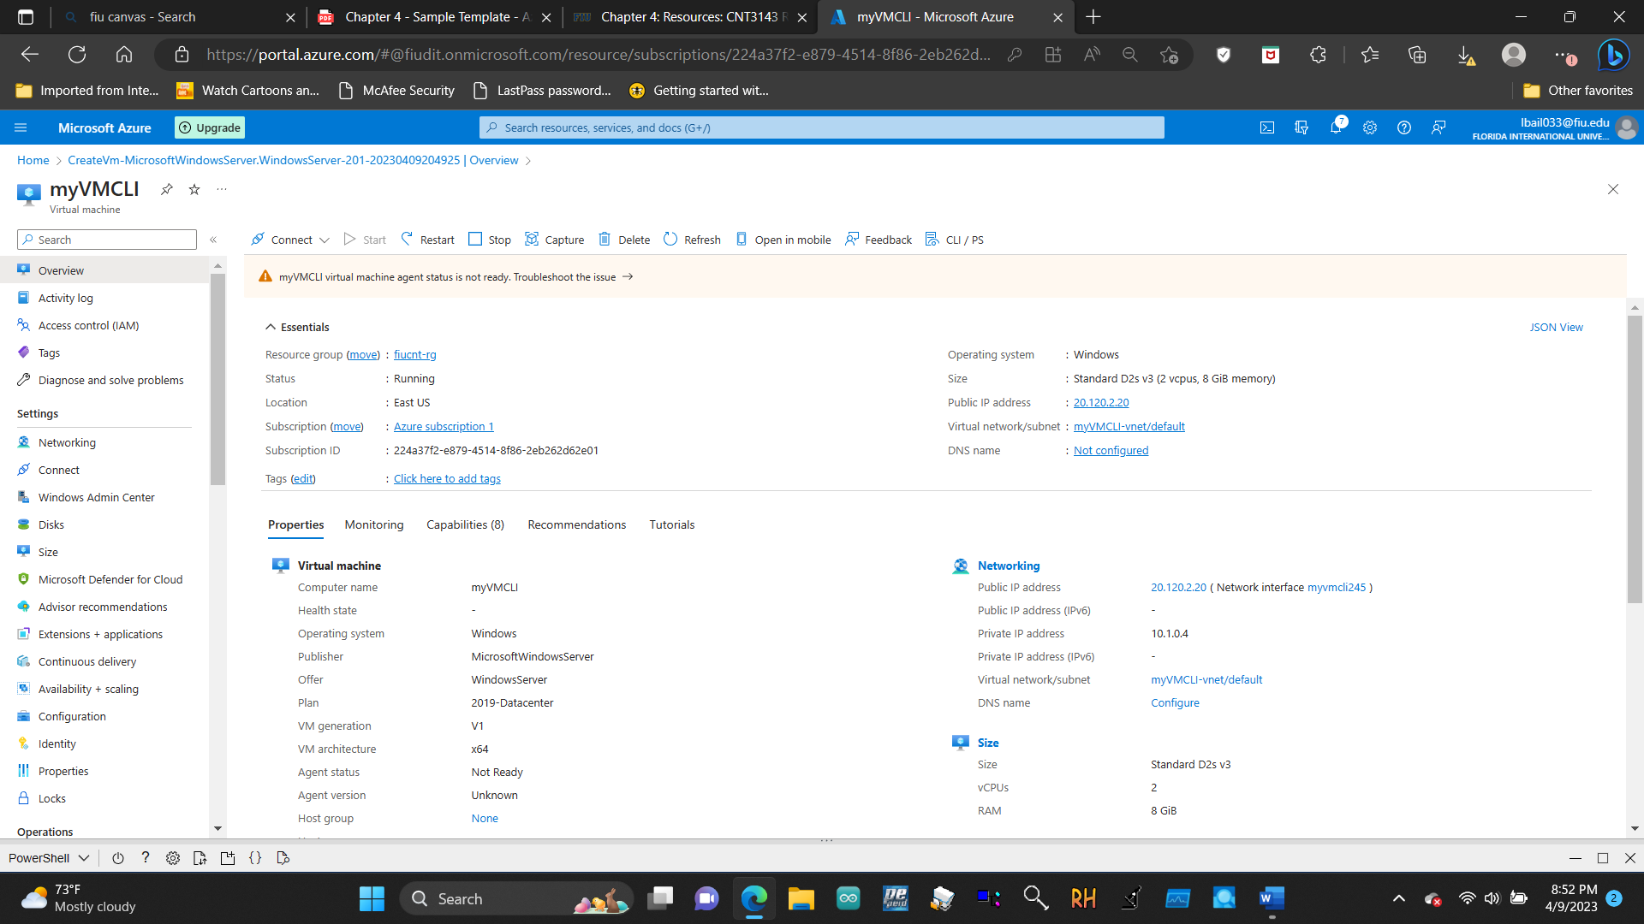

4.5.3 Execute commands in the Cloud Shell

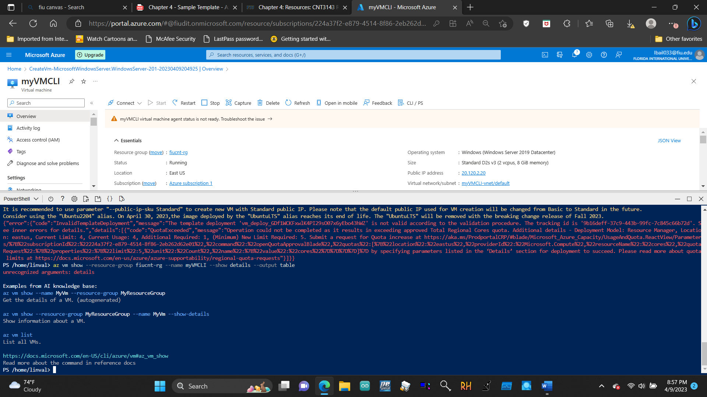

5.1.1 Create a virtual machine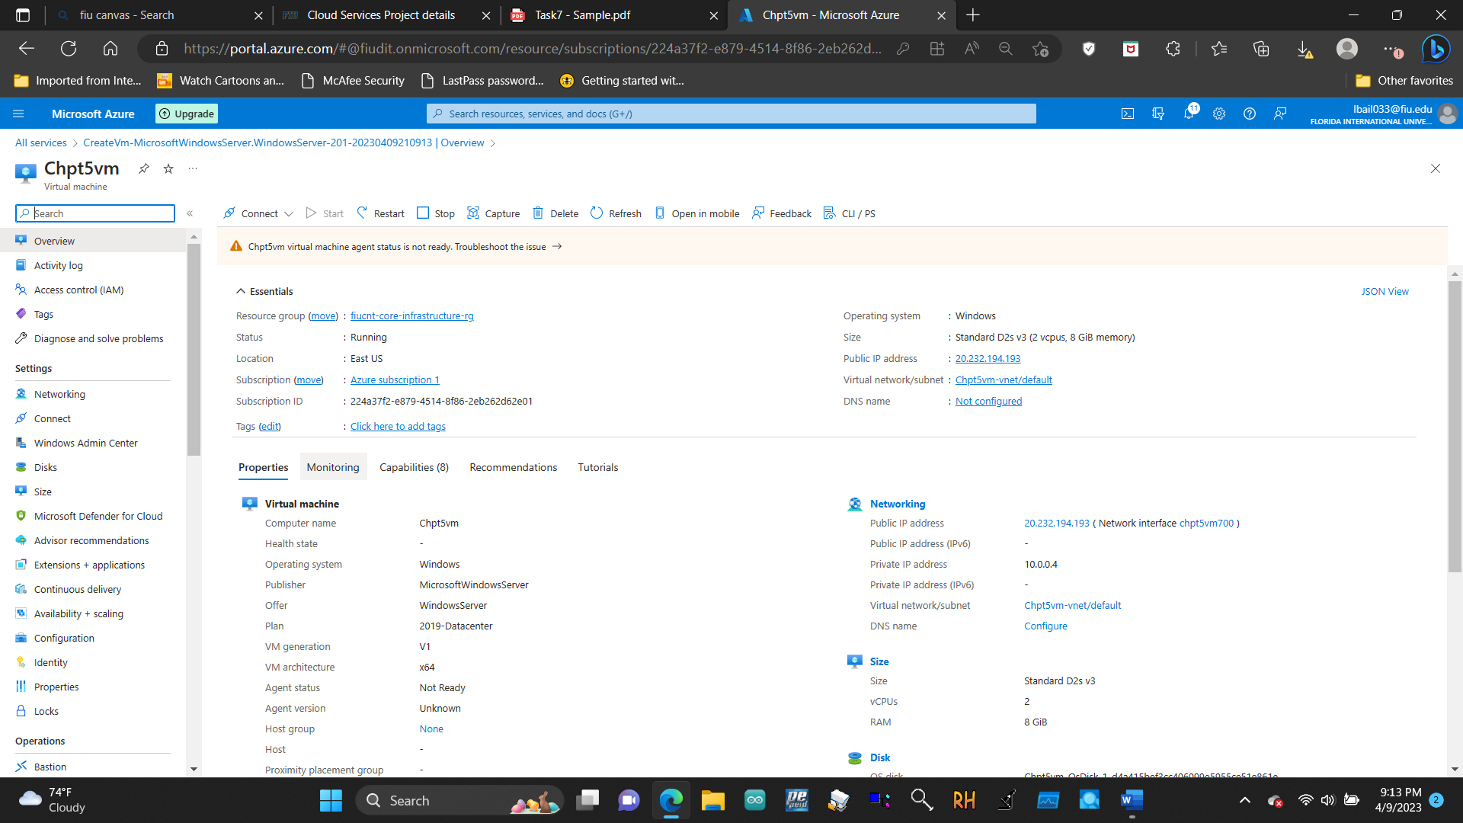

5.1.2 Create a network security group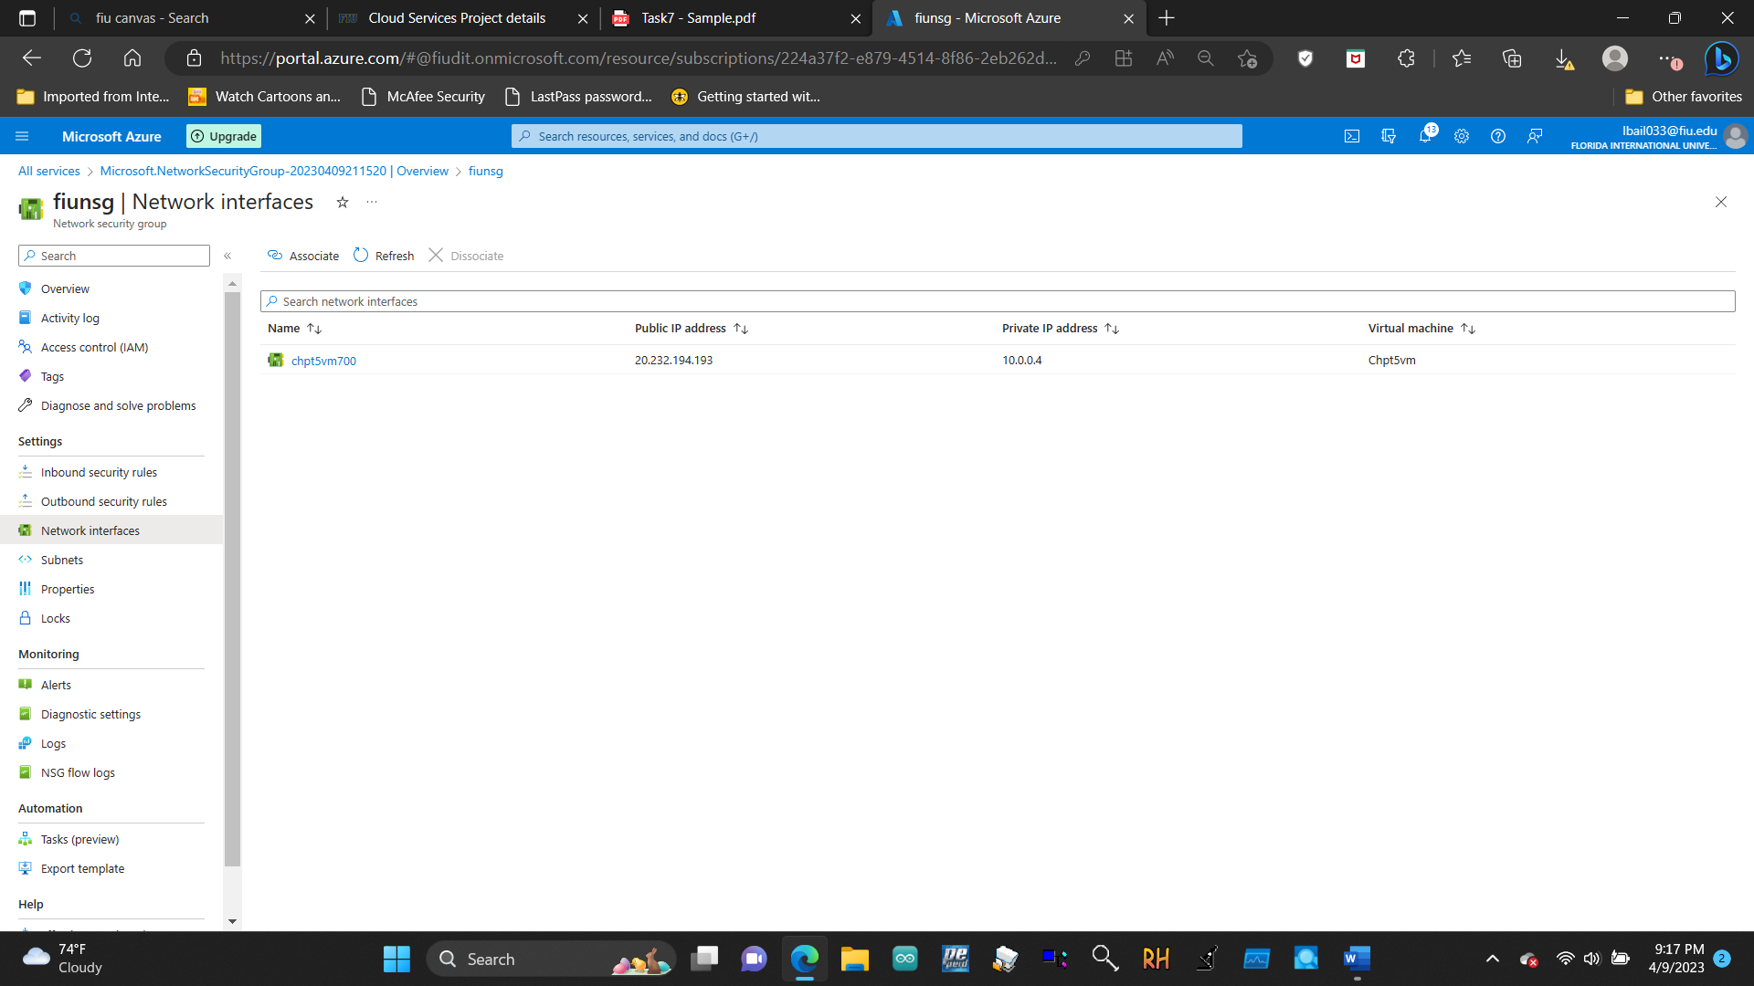

5.1.3 Configure an inbound security port rule to allow RDP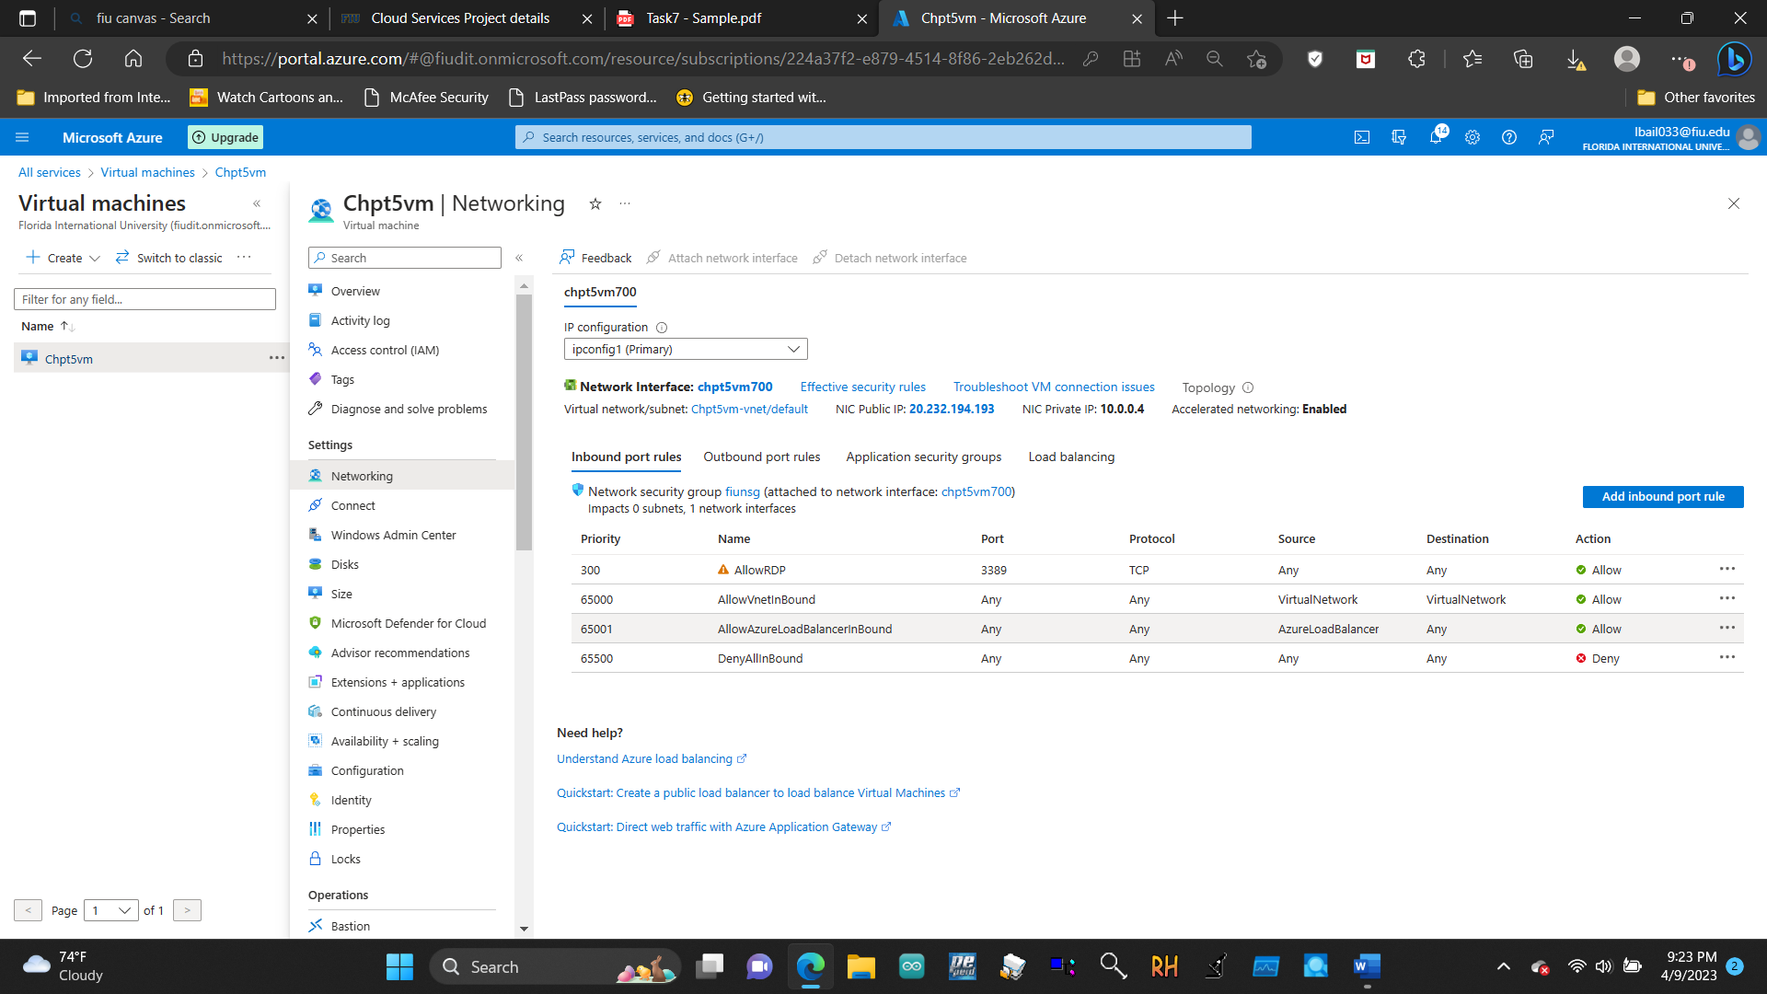

5.1.4 Configure an outbound security port rule to deny Internet access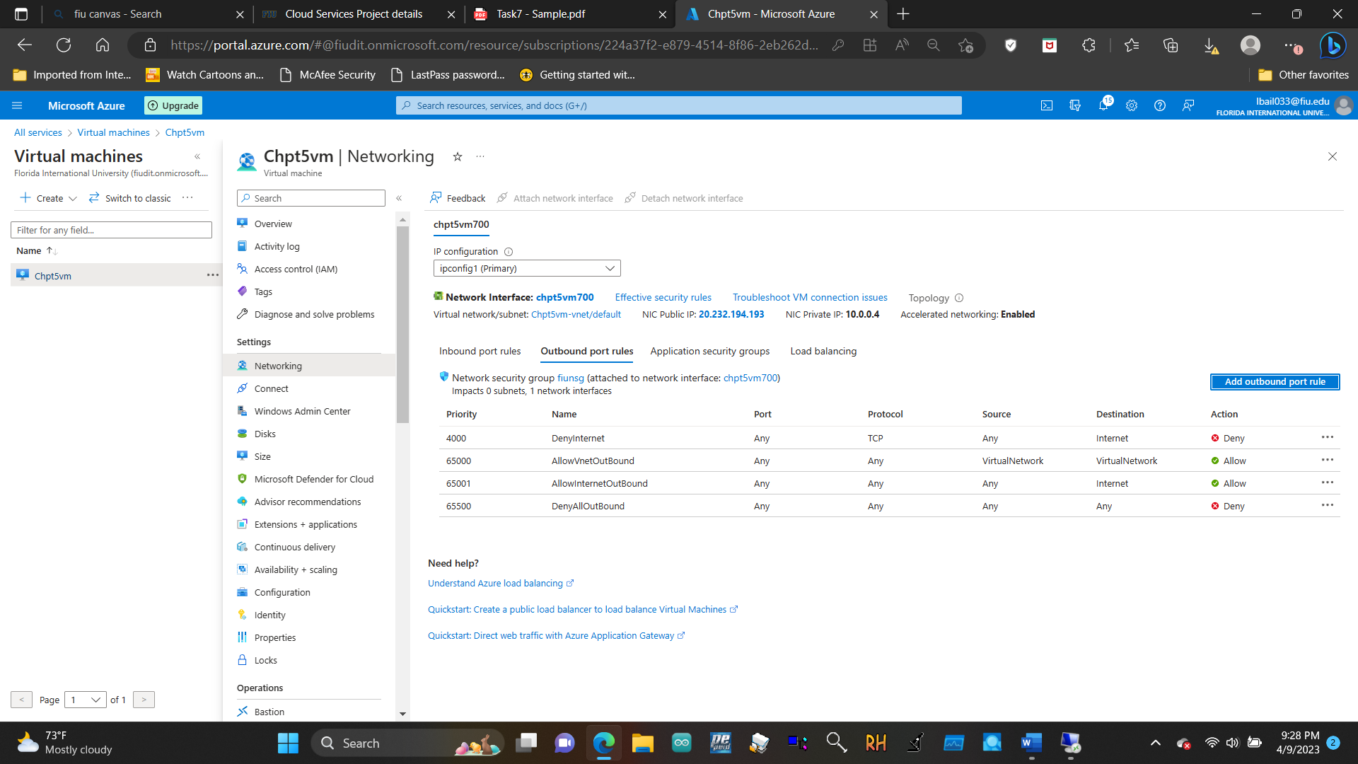

5.2.1 Create an Azure Key Vault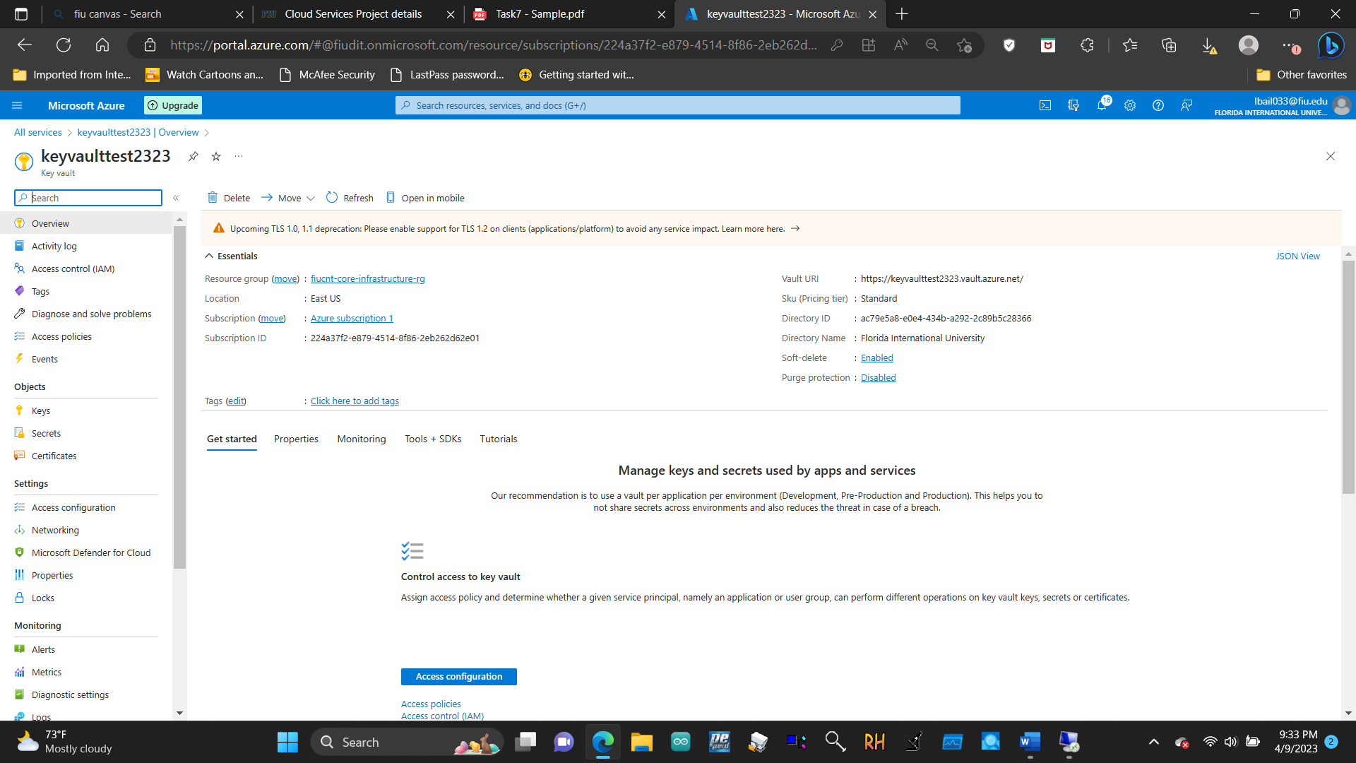

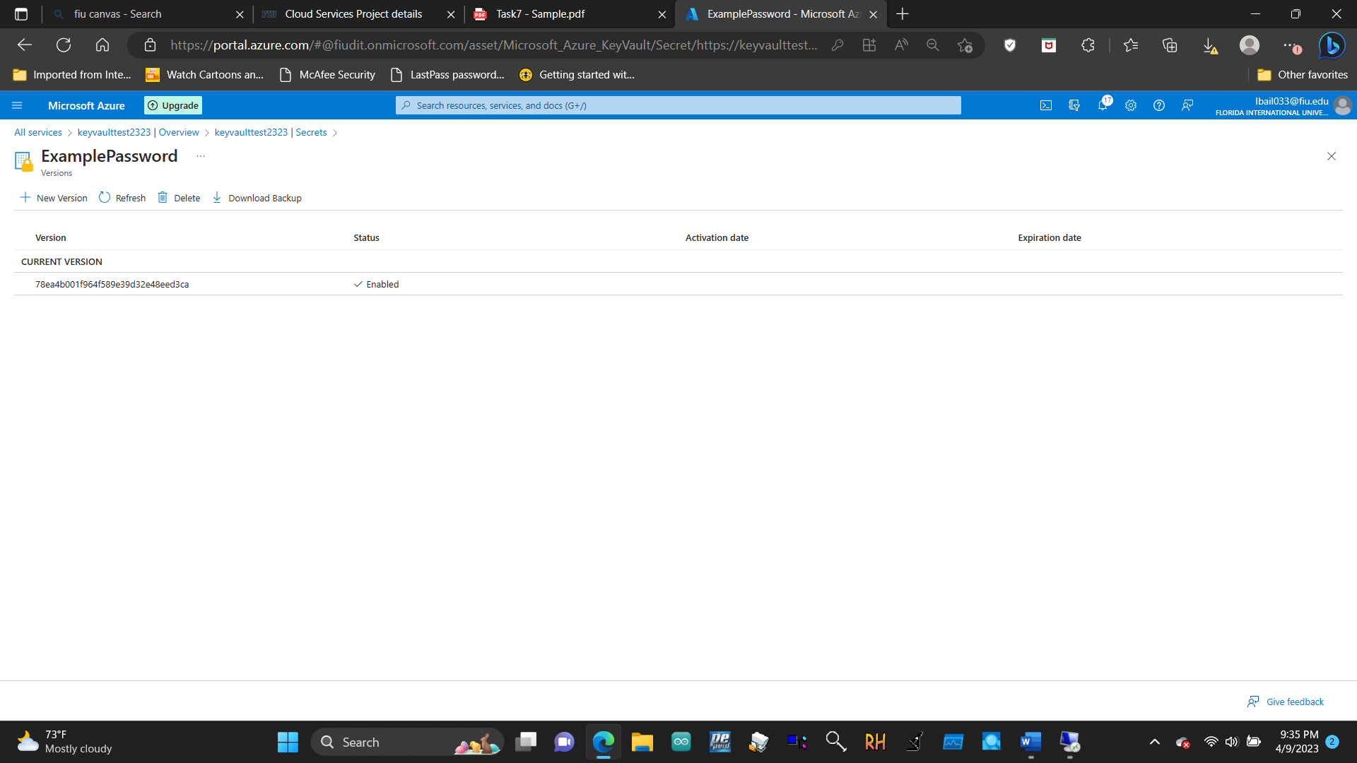

5.2.2 Add a secret to the Key Vault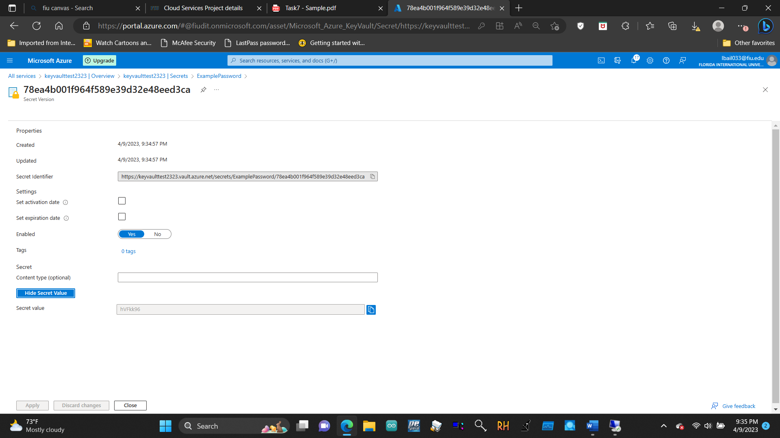

5.3.2 Test allowed location policy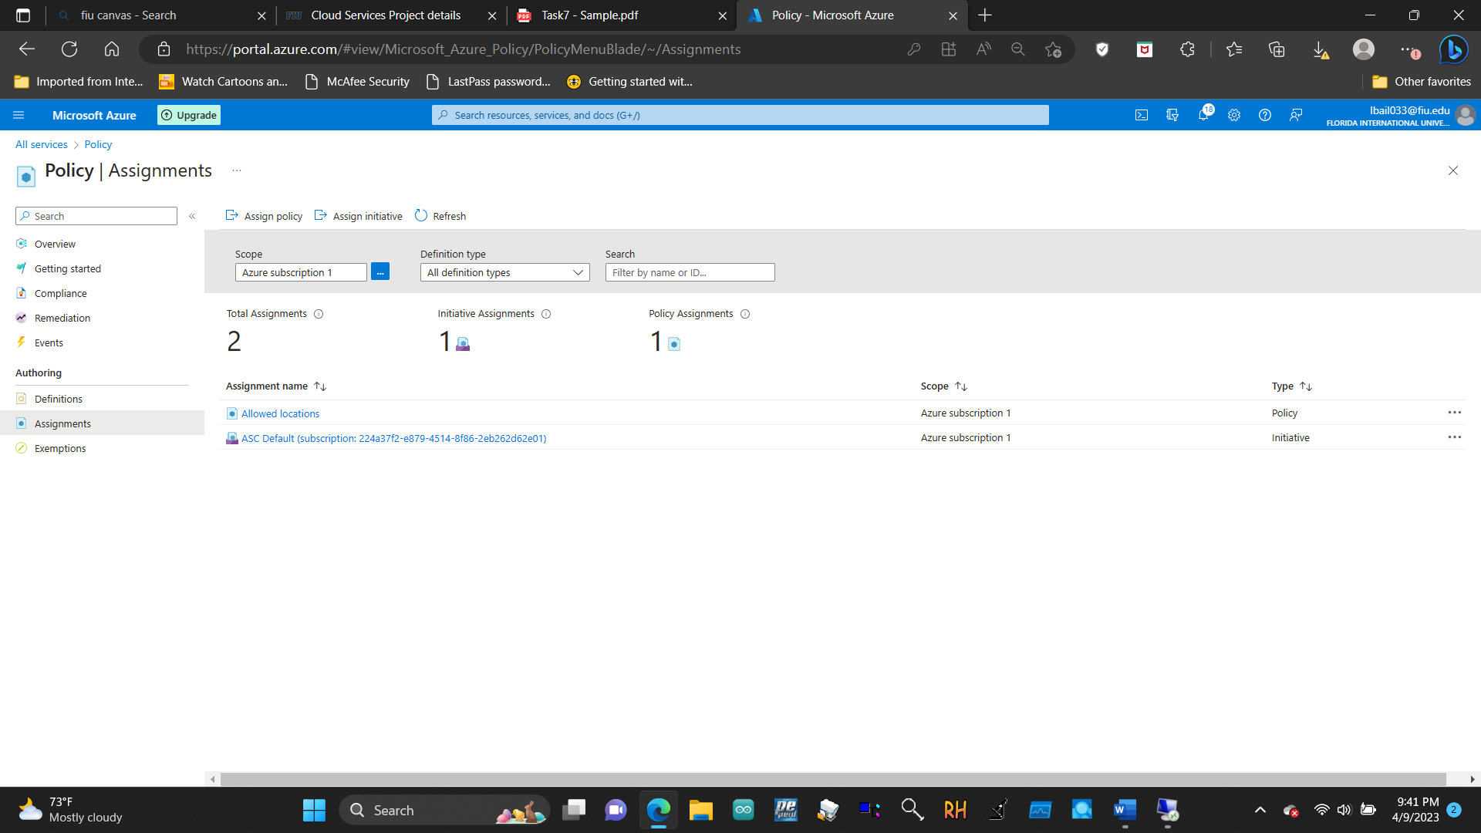

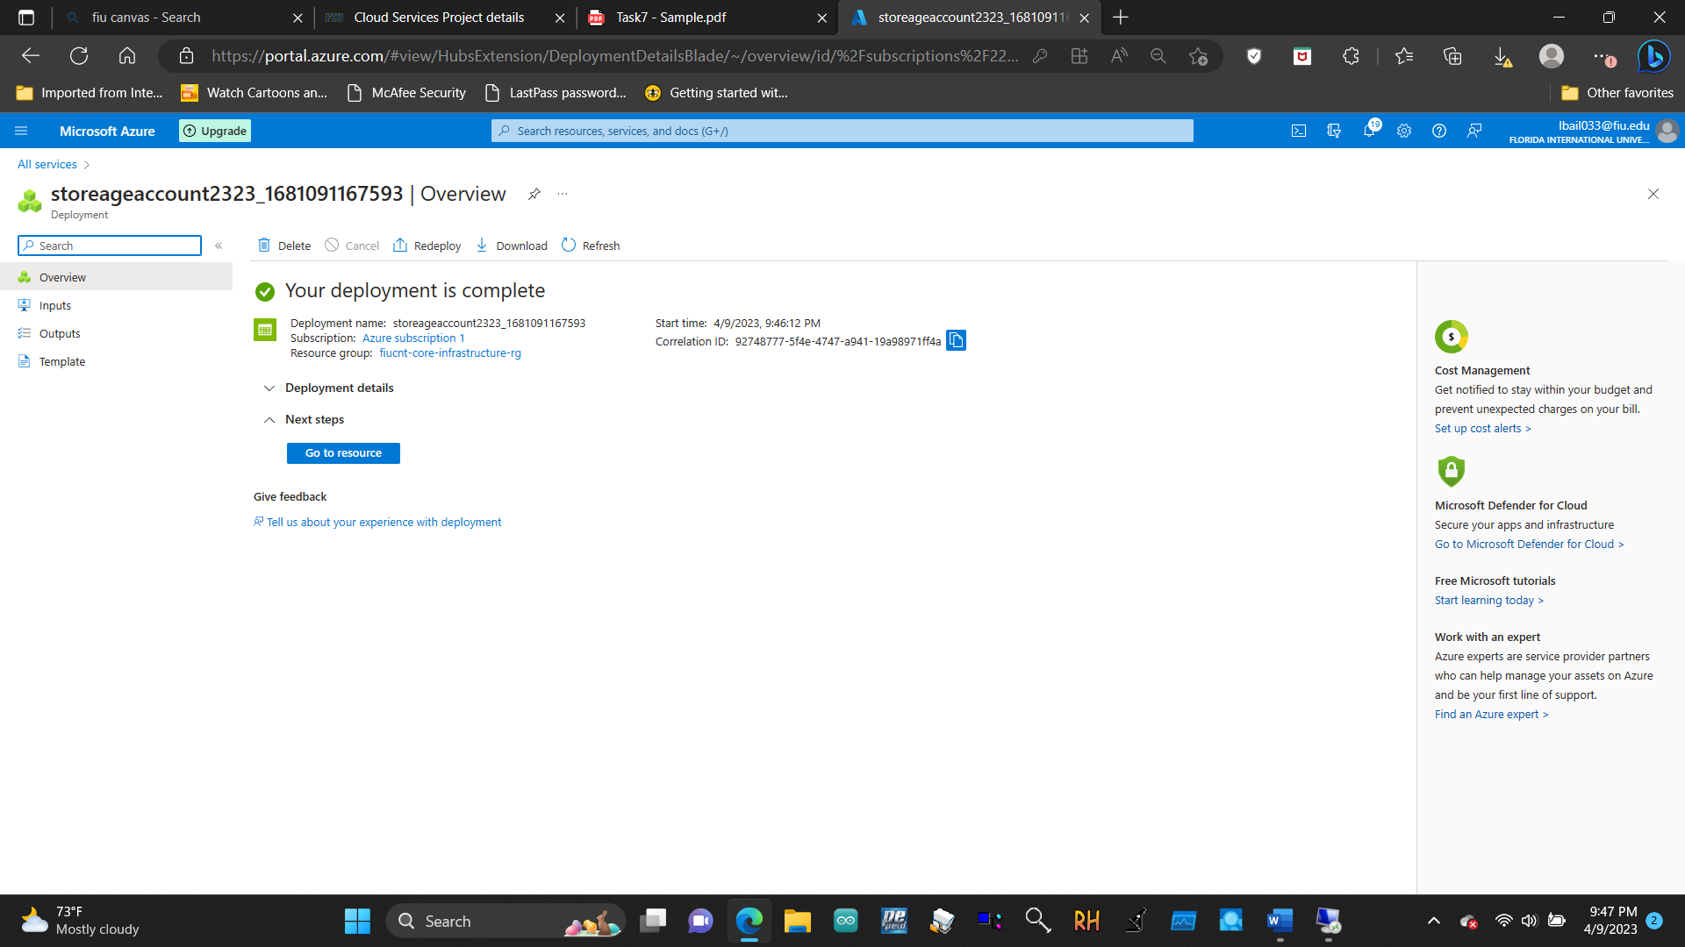

5.3.3 Delete the policy assignment

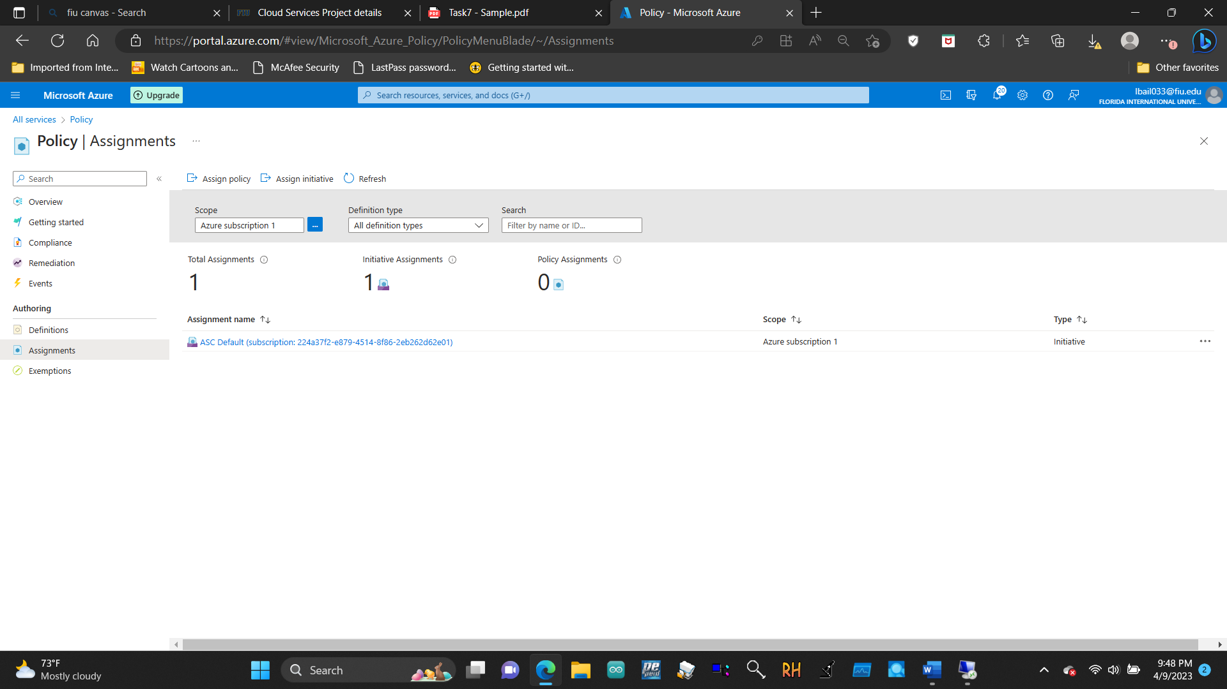

5.4.1 View and assign roles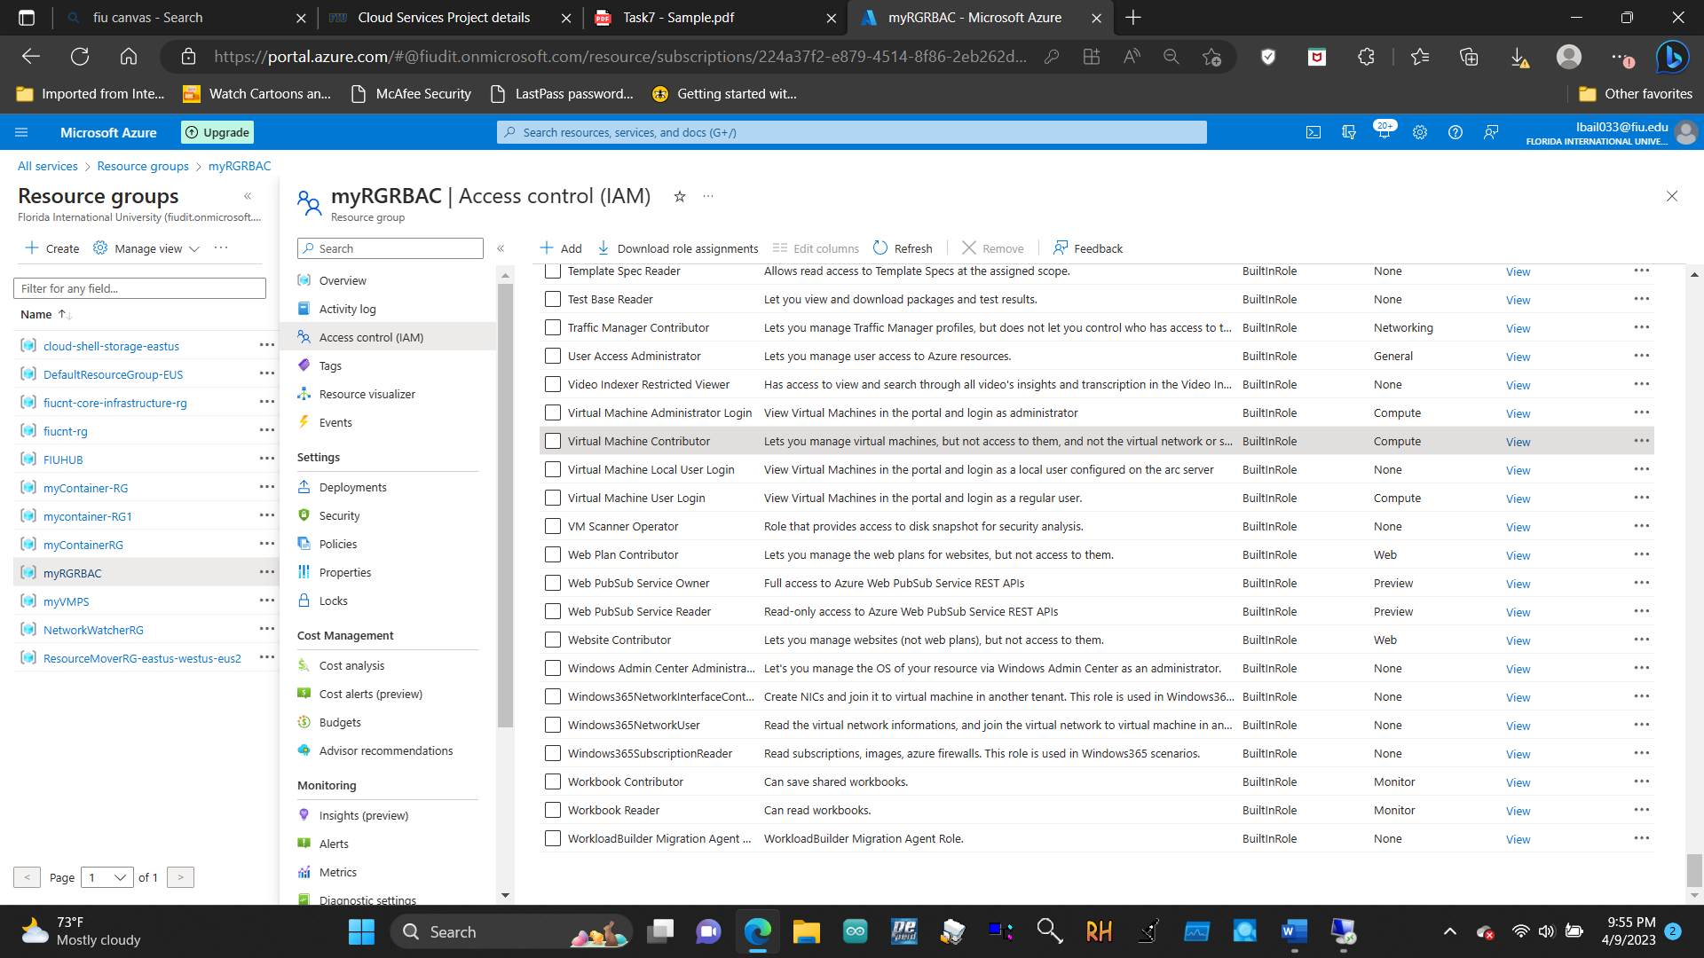

5.4.2 Monitor role assignments and remove a role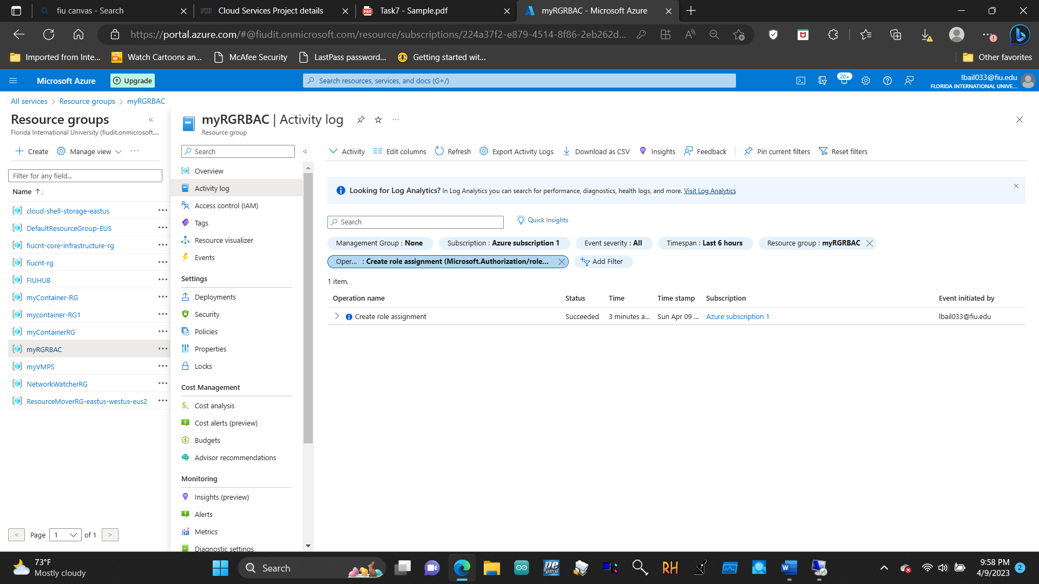

5.5.1 Create a resource group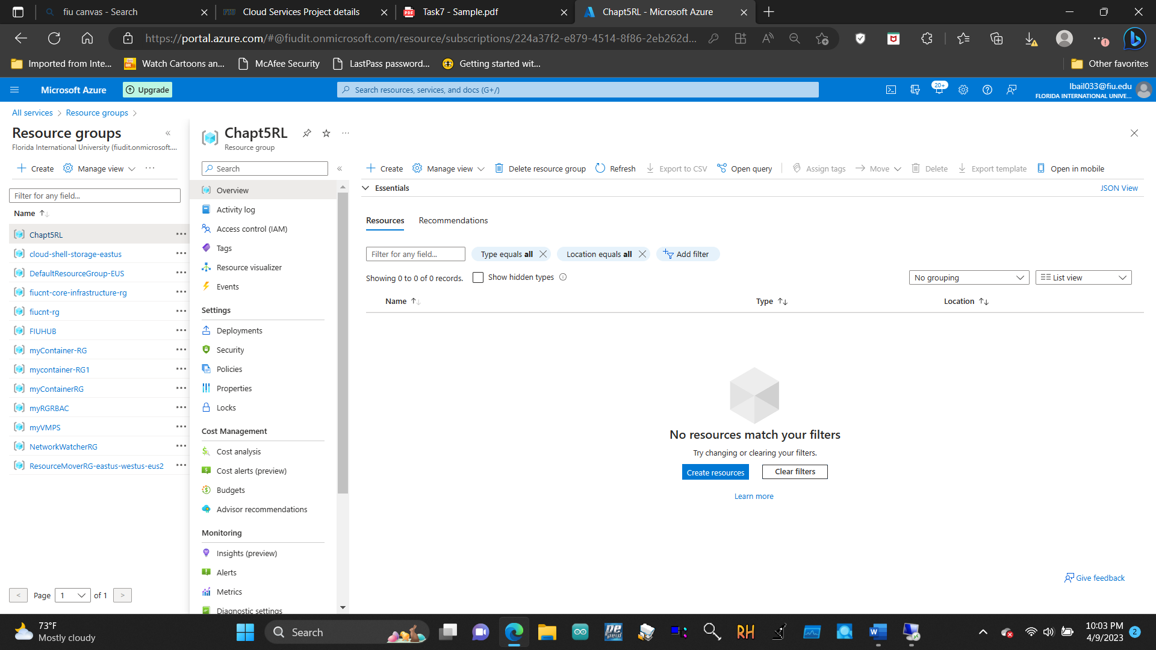

5.5.2 Add a lock to the resource group and test deletion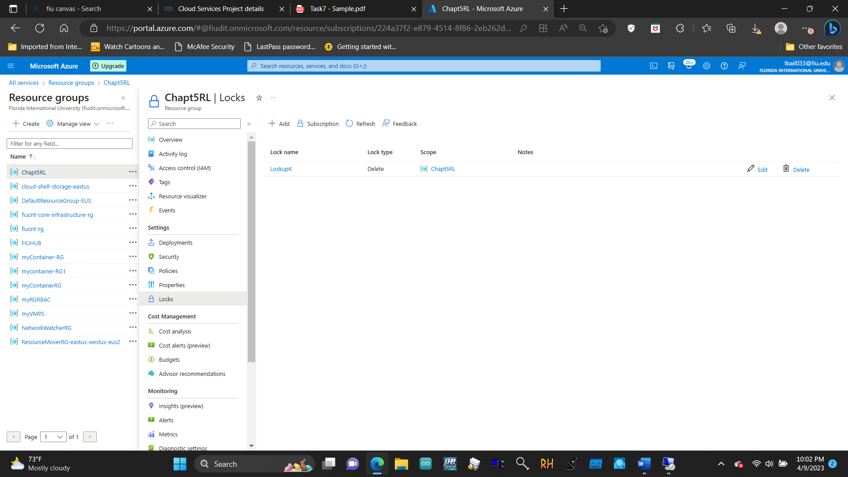

5.5.3 Test deleting a member of the resource group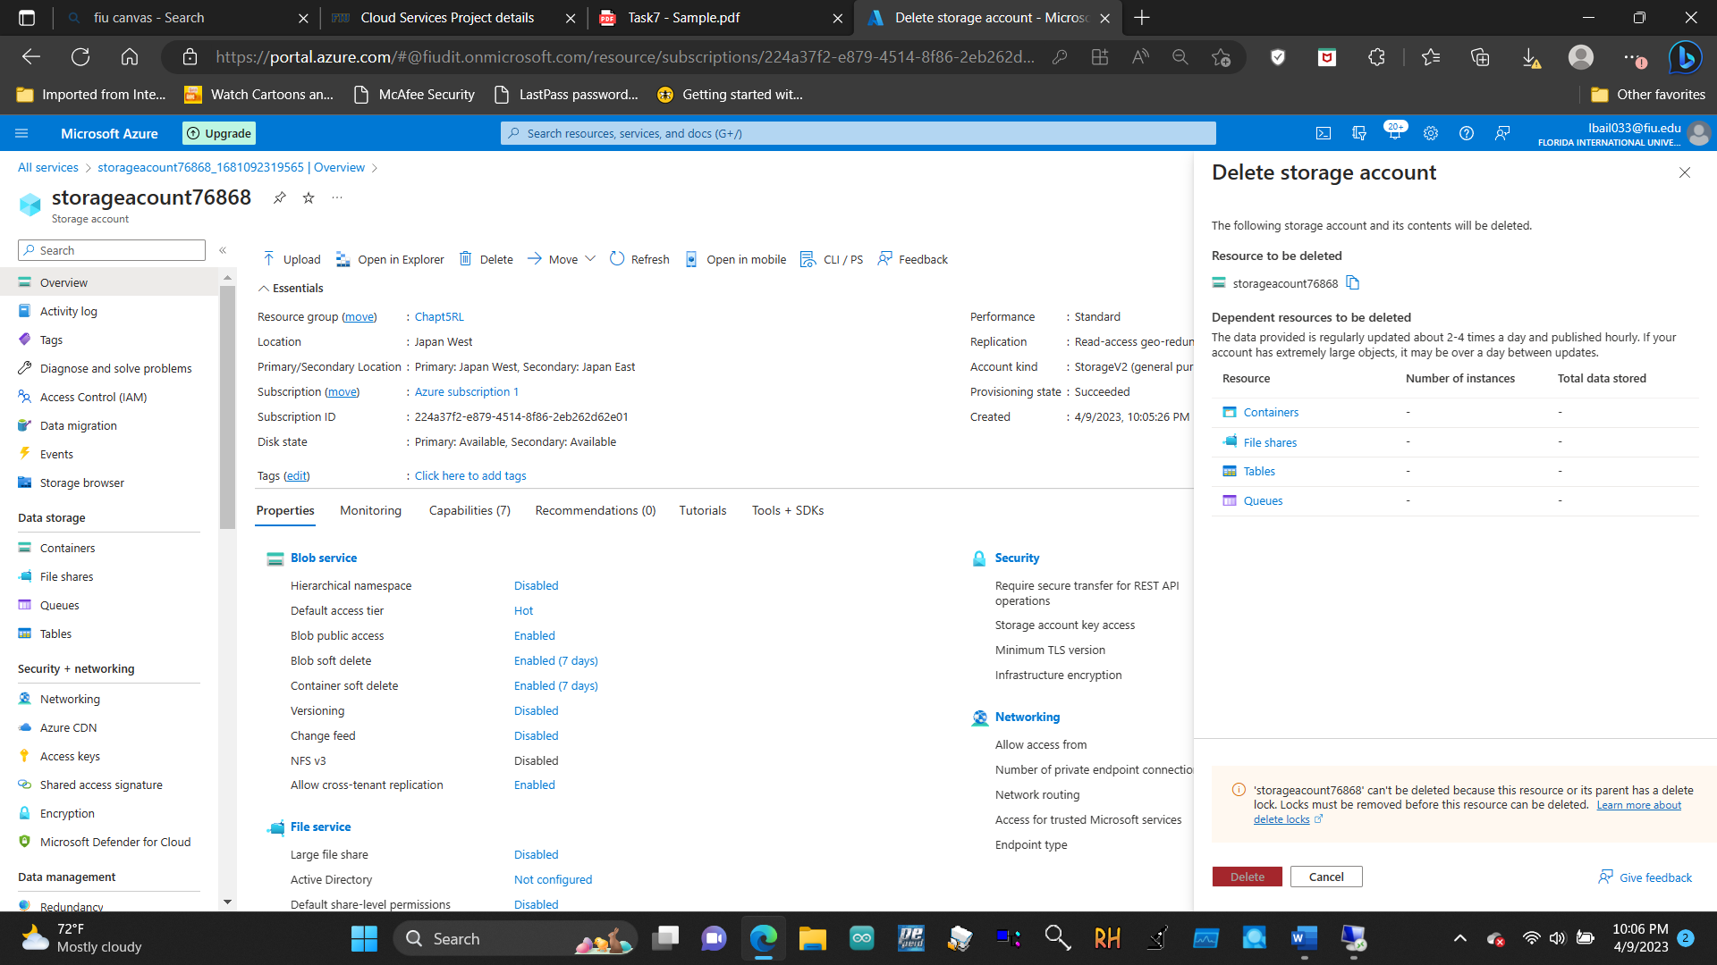

5.5.4 Remove the resource lock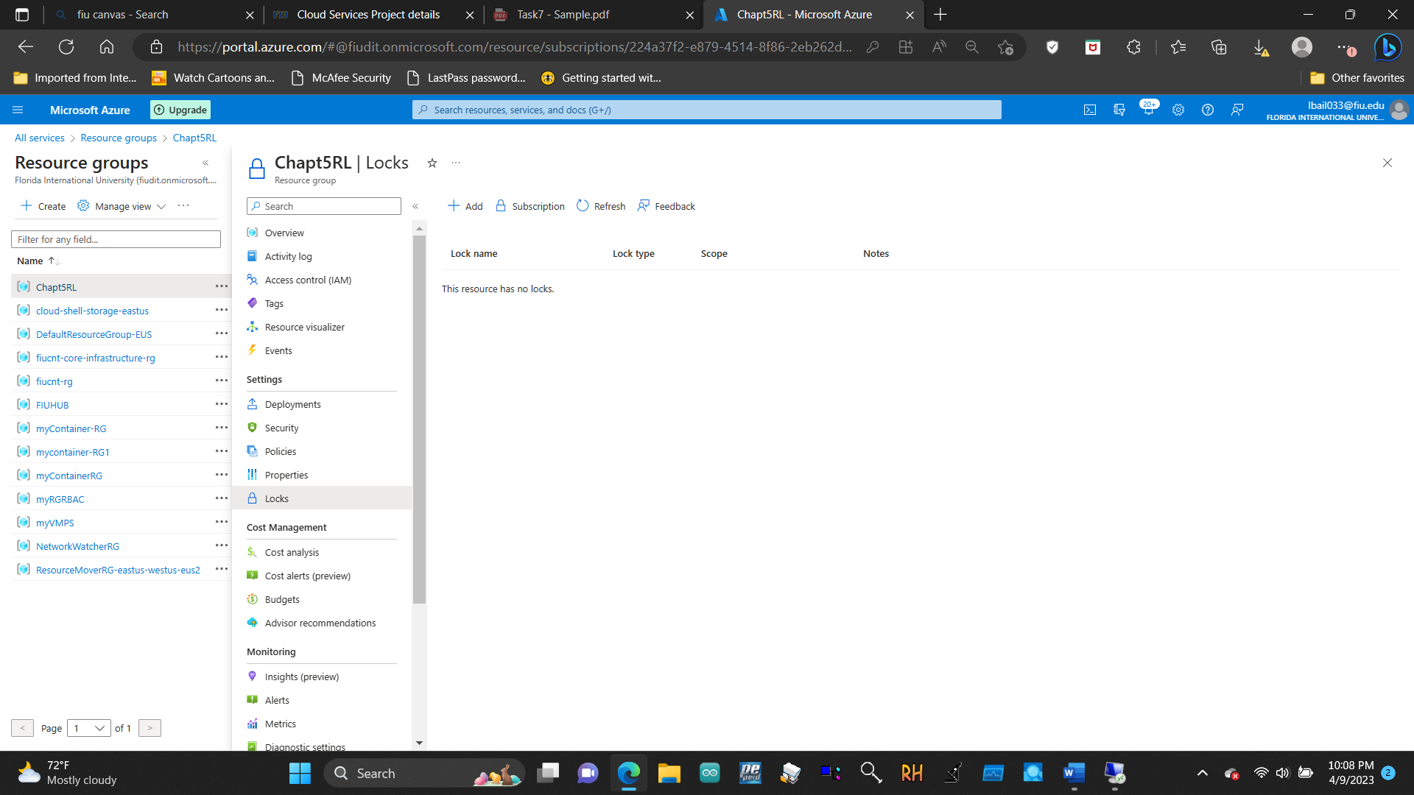

5.7.1 Access the Trust Center

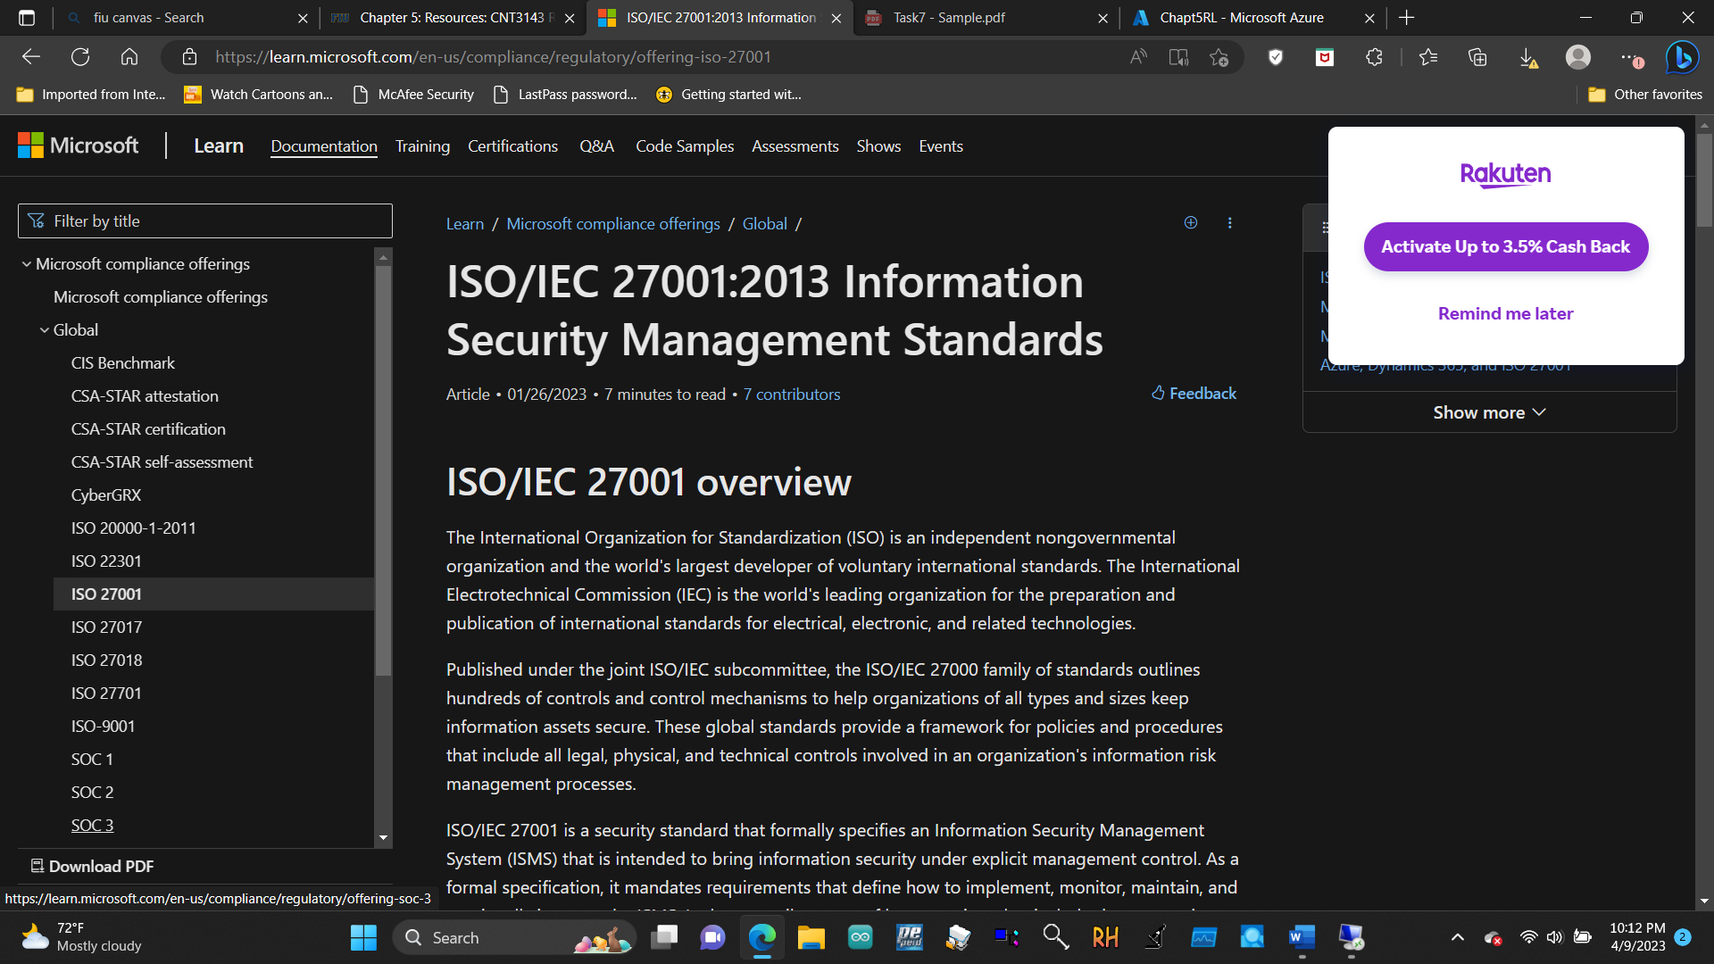

5.7.2 Access the Service Trust Portal (STP)

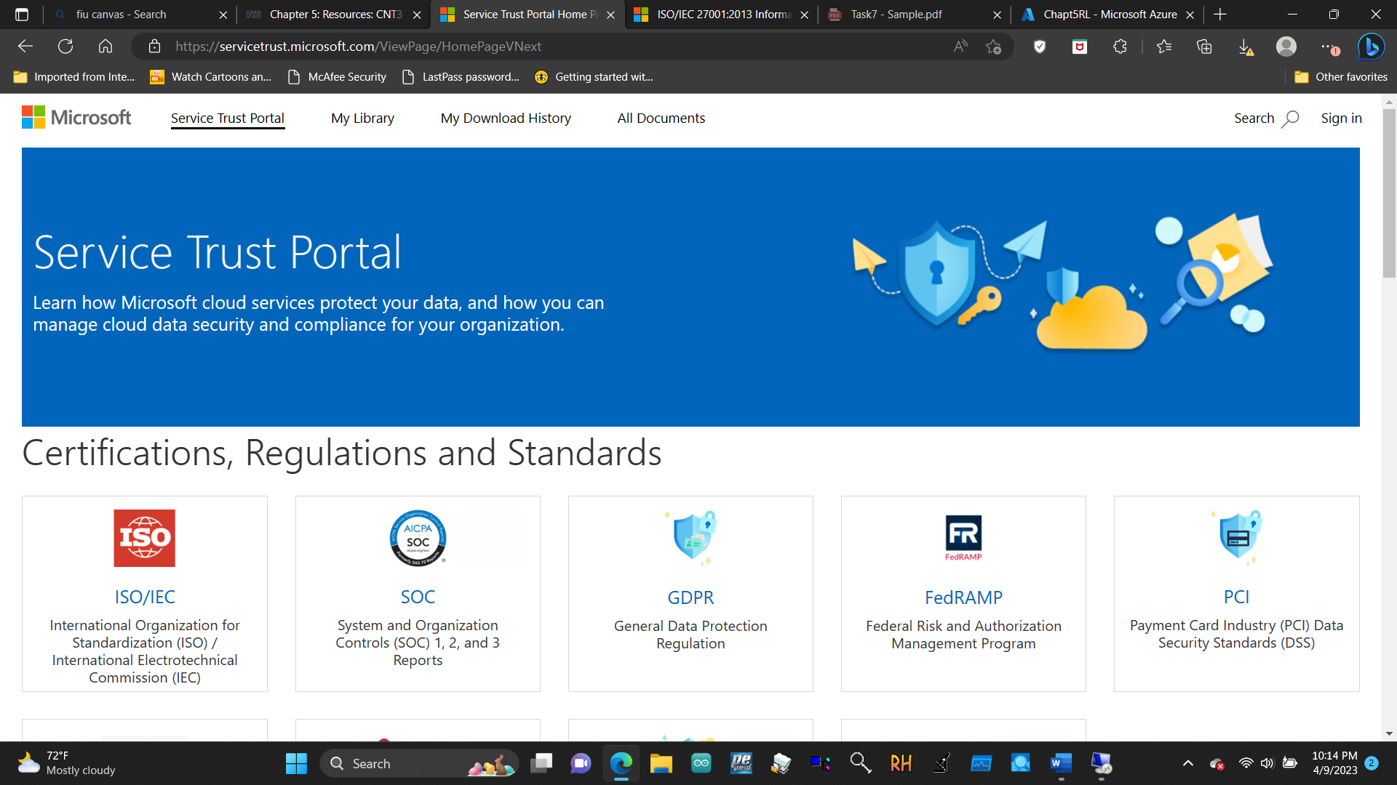

5.7.3 Access the Compliance Manager

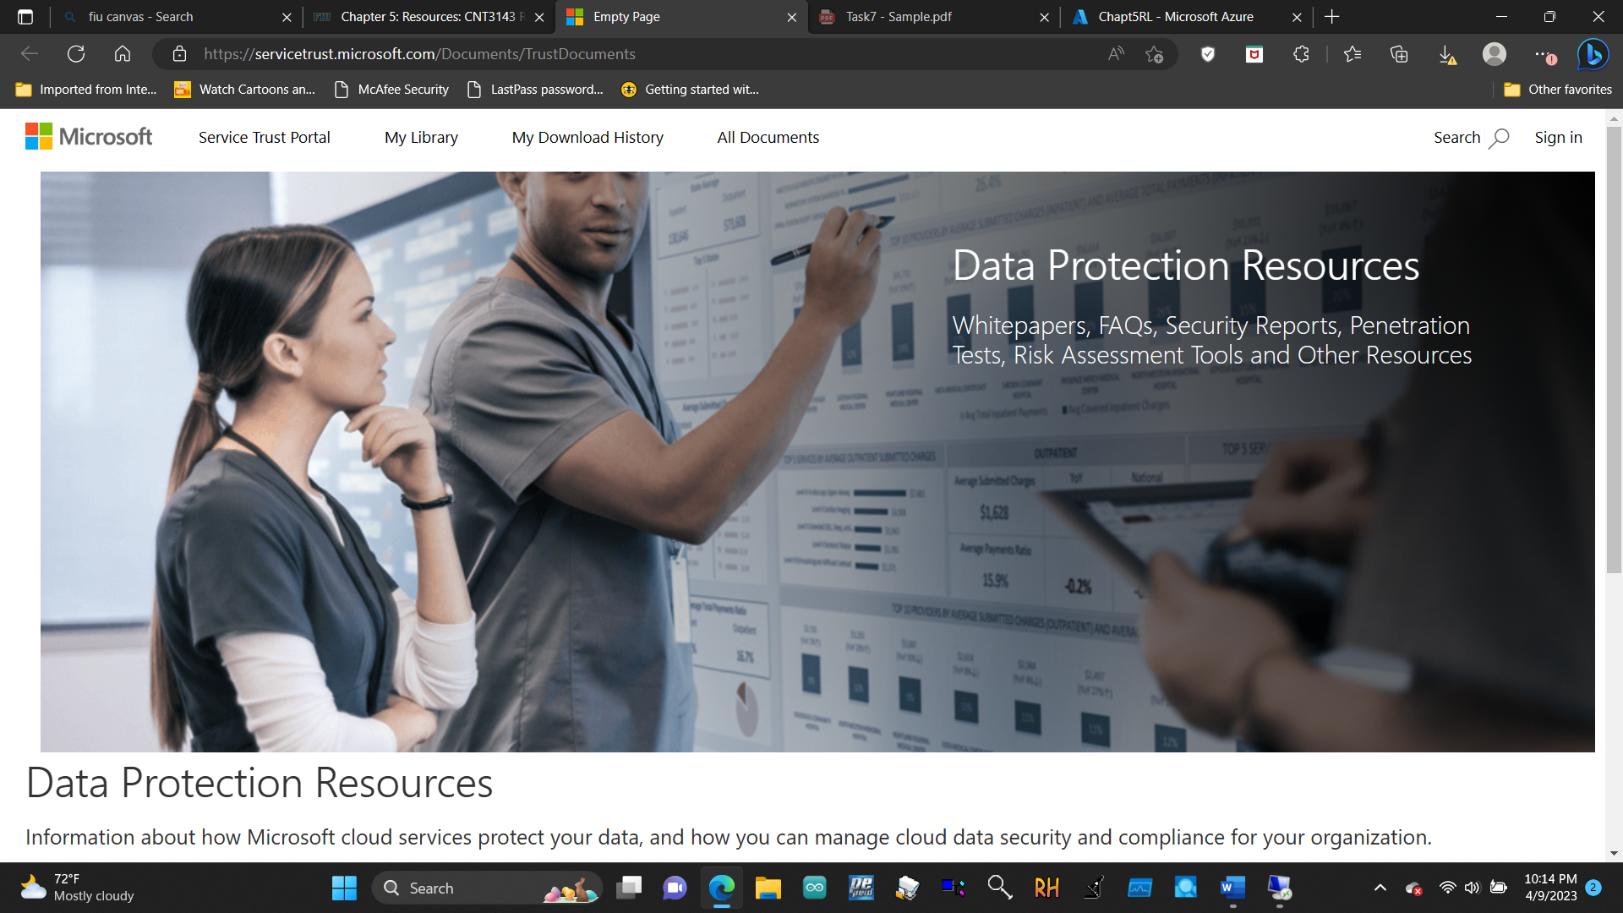

7.1.1 Create an IoT hub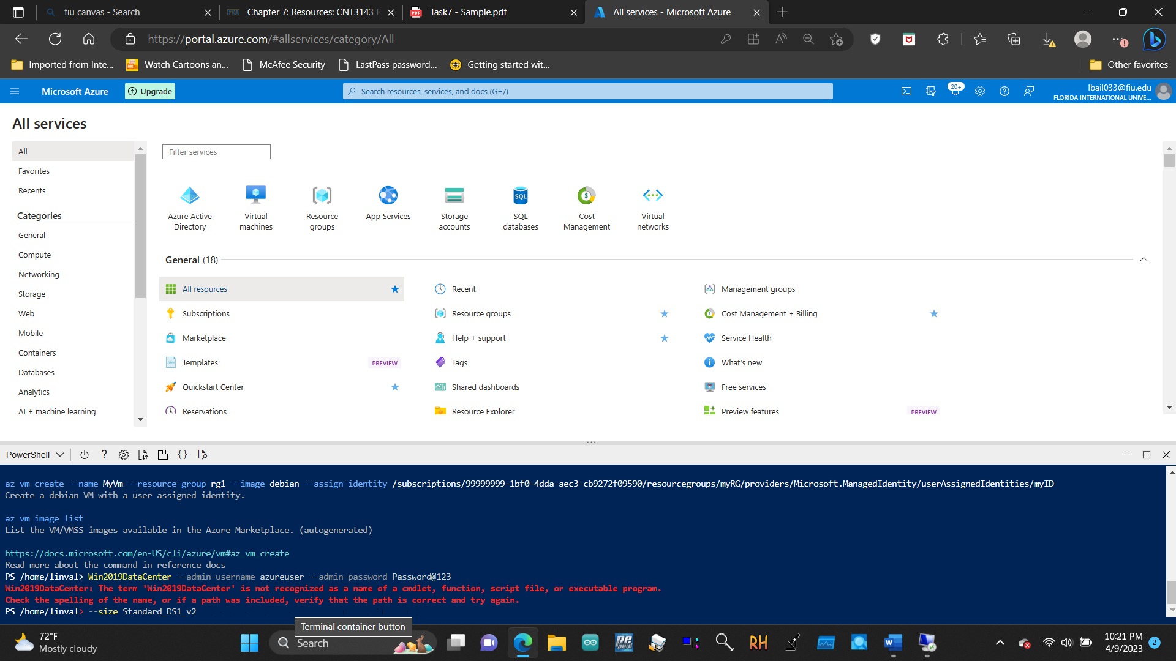

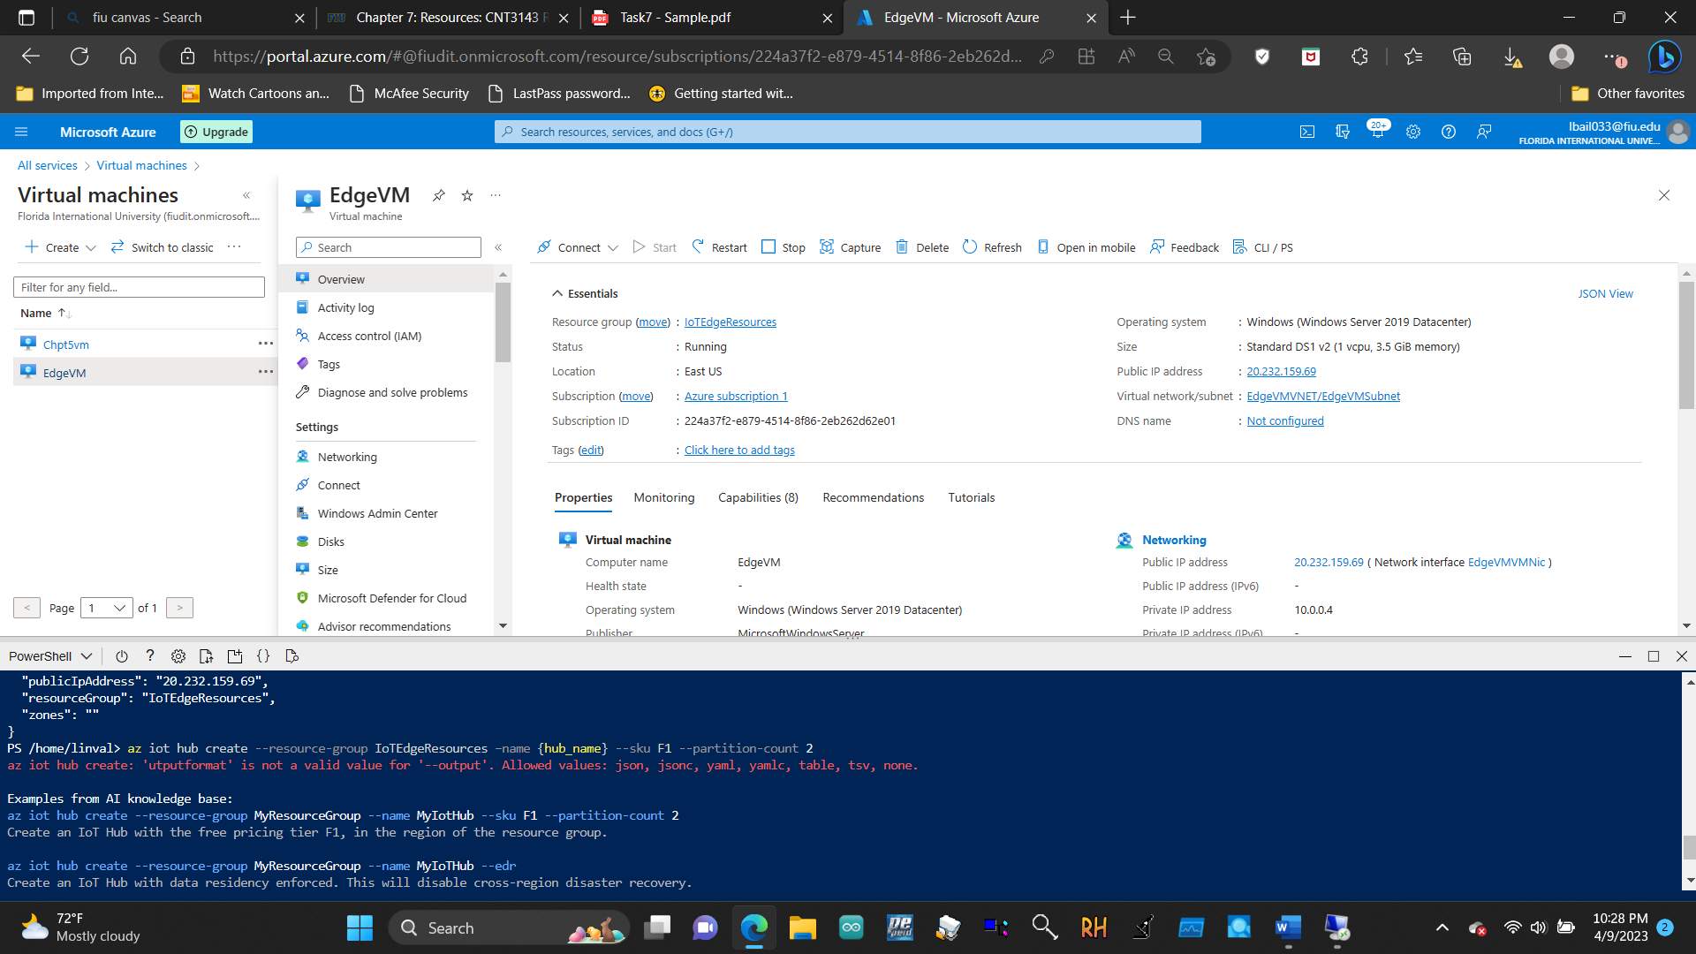

7.1.2 Register an IoT Edge device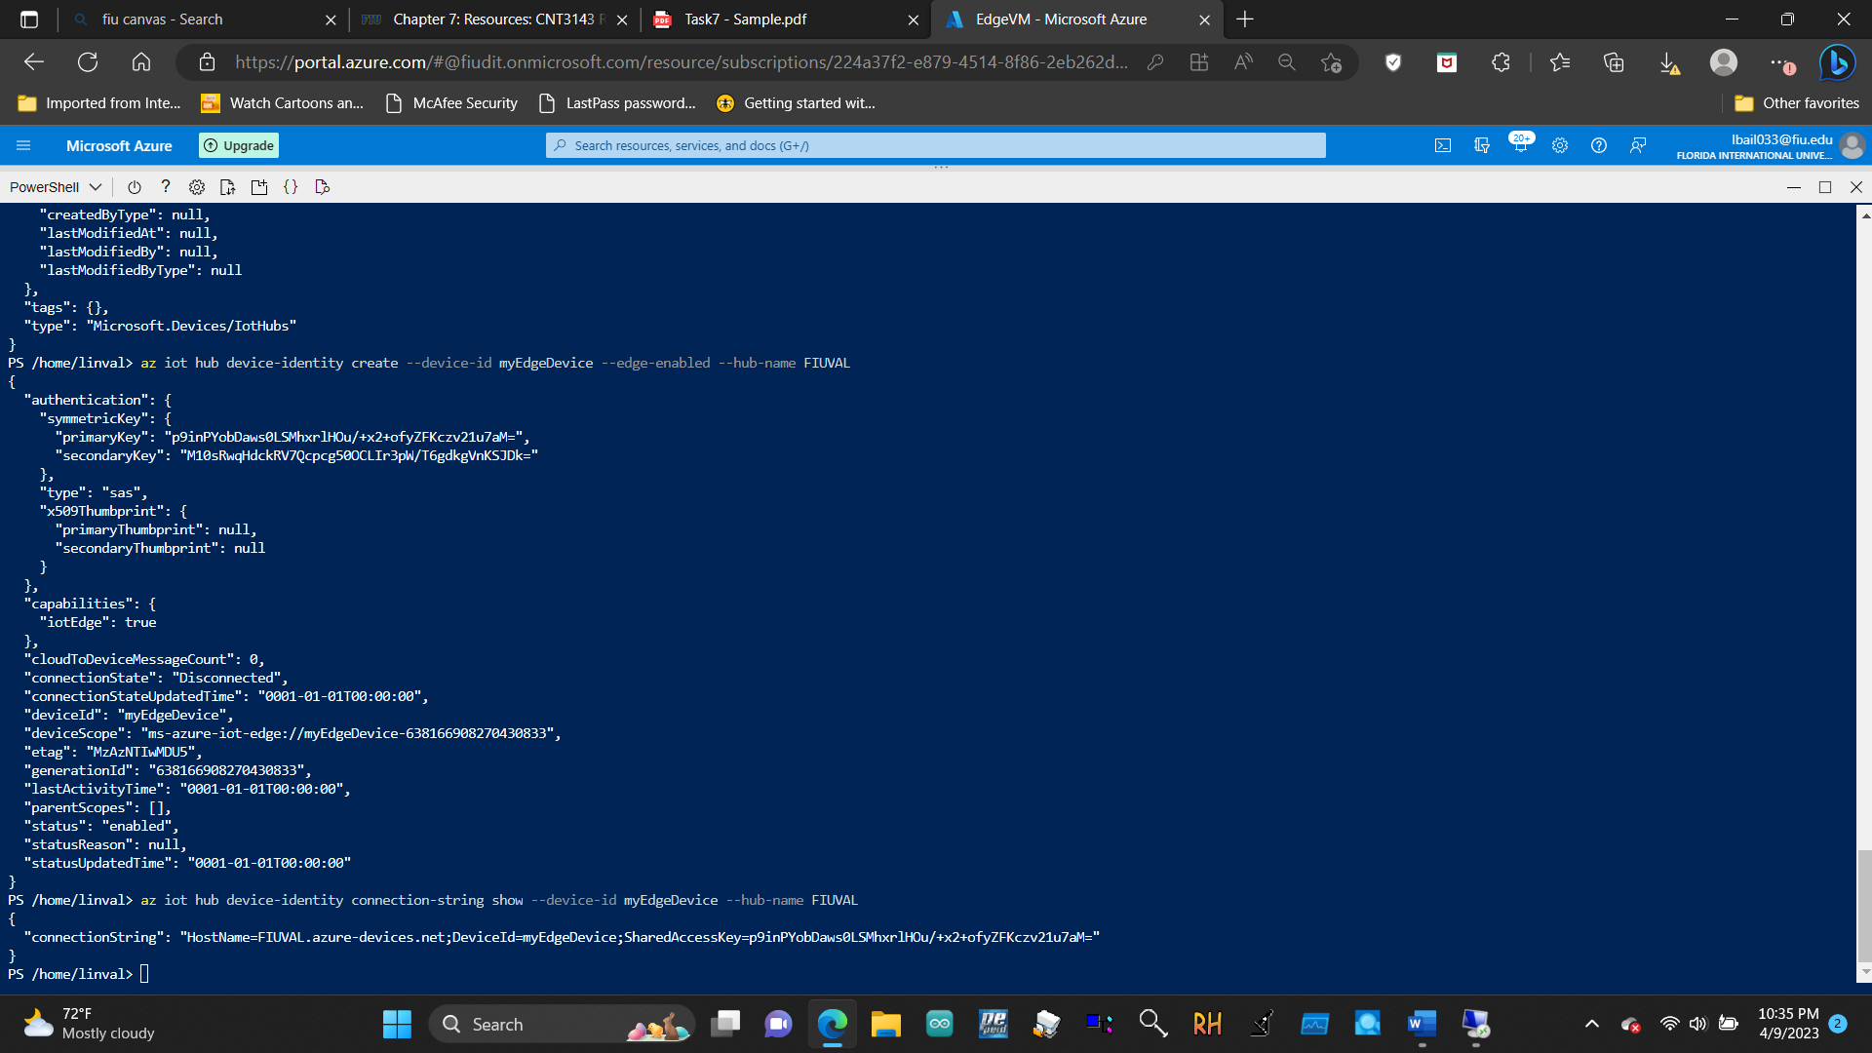

7.1.3 Install and start the IoT Edge runtime

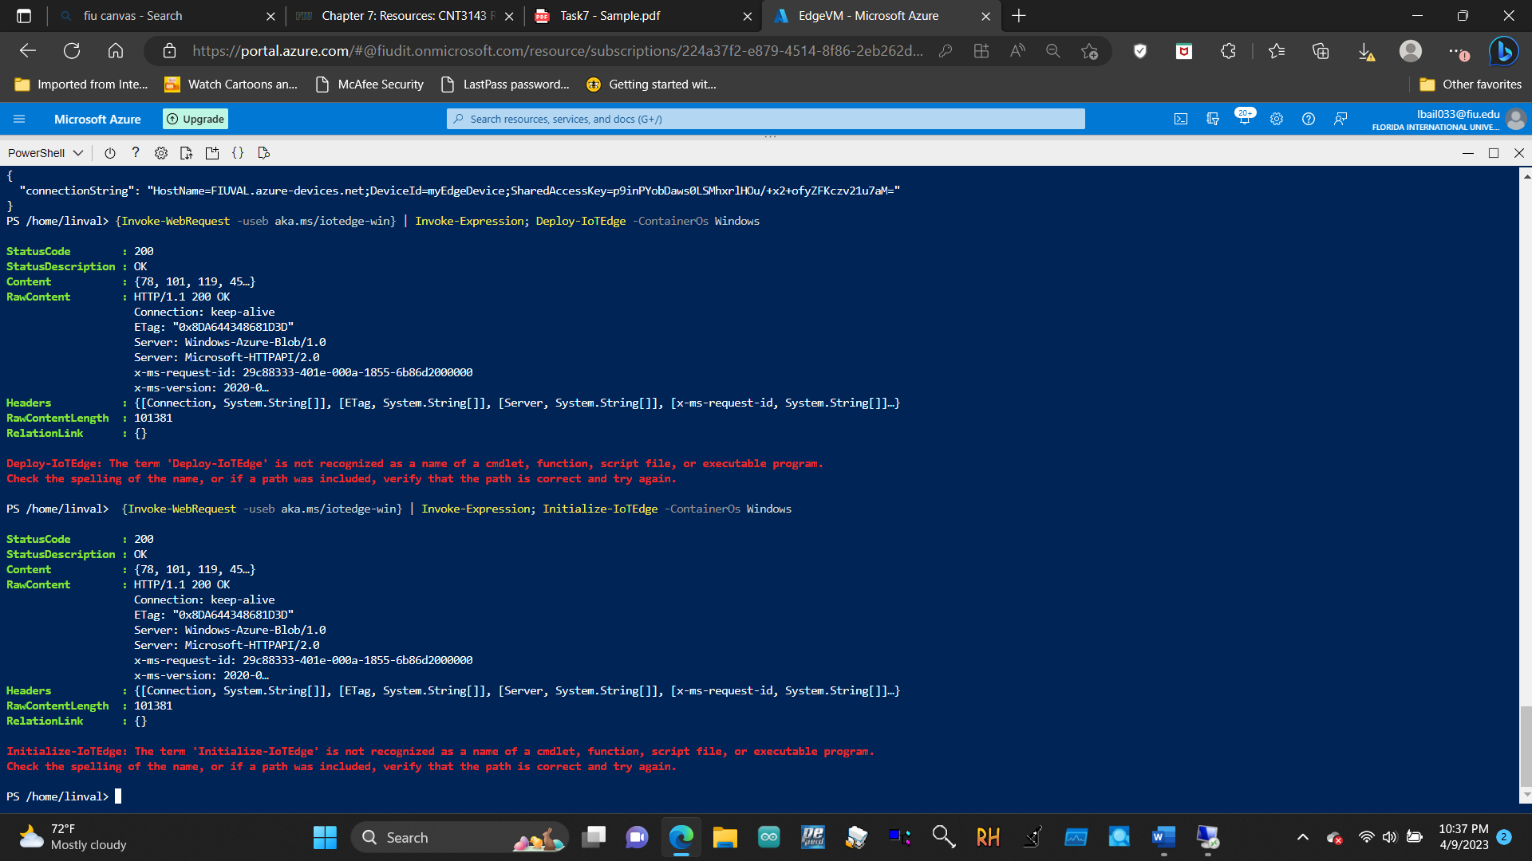

7.1.4 Deploy a module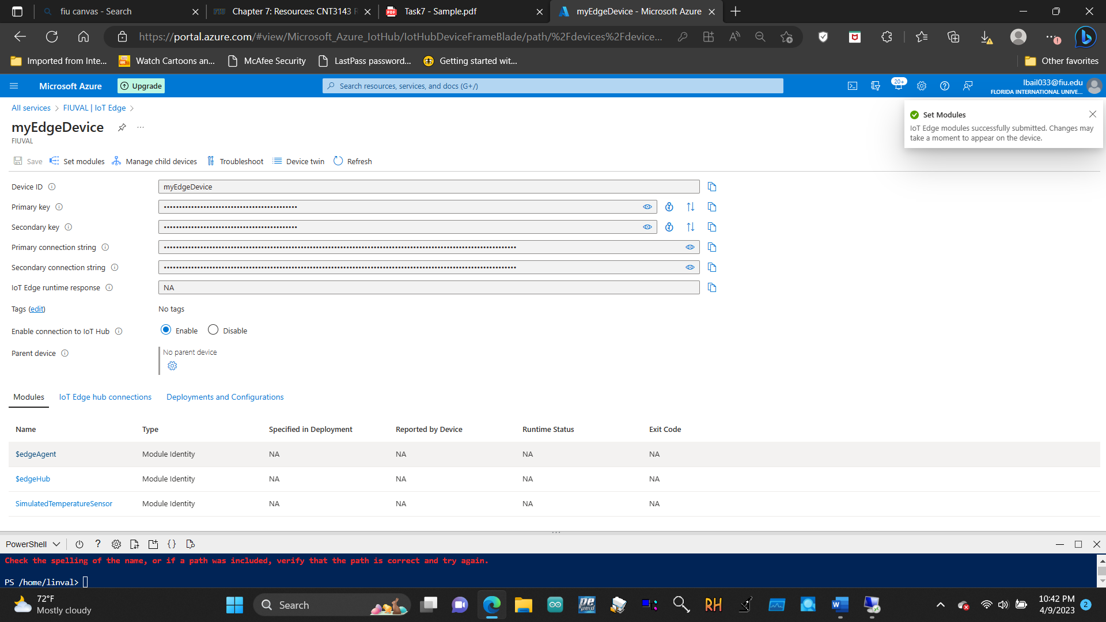

8.1.1 Create a workspace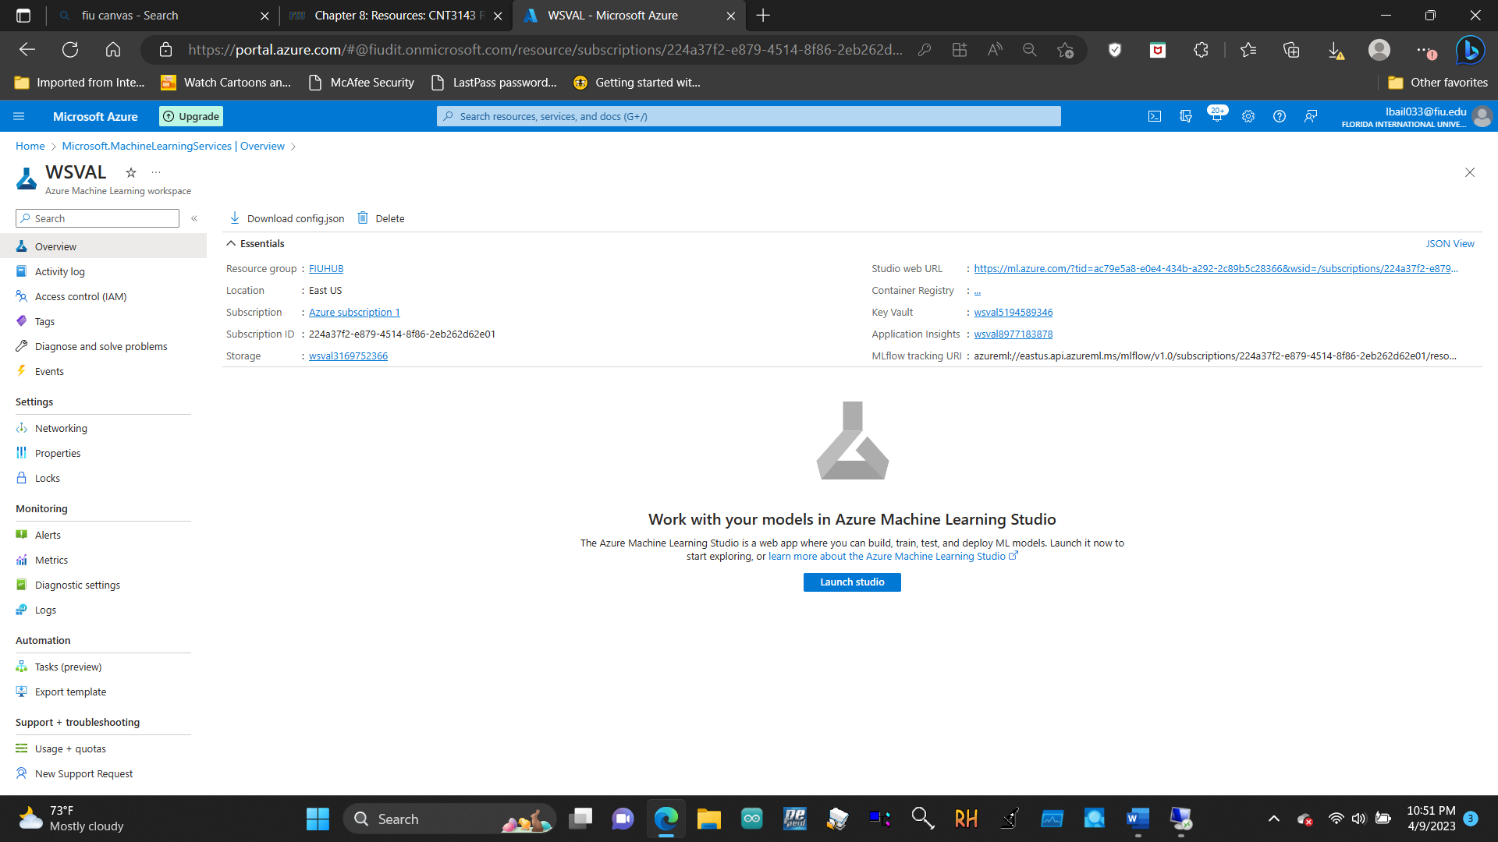

8.1.2 Start Azure Machine Learning Studio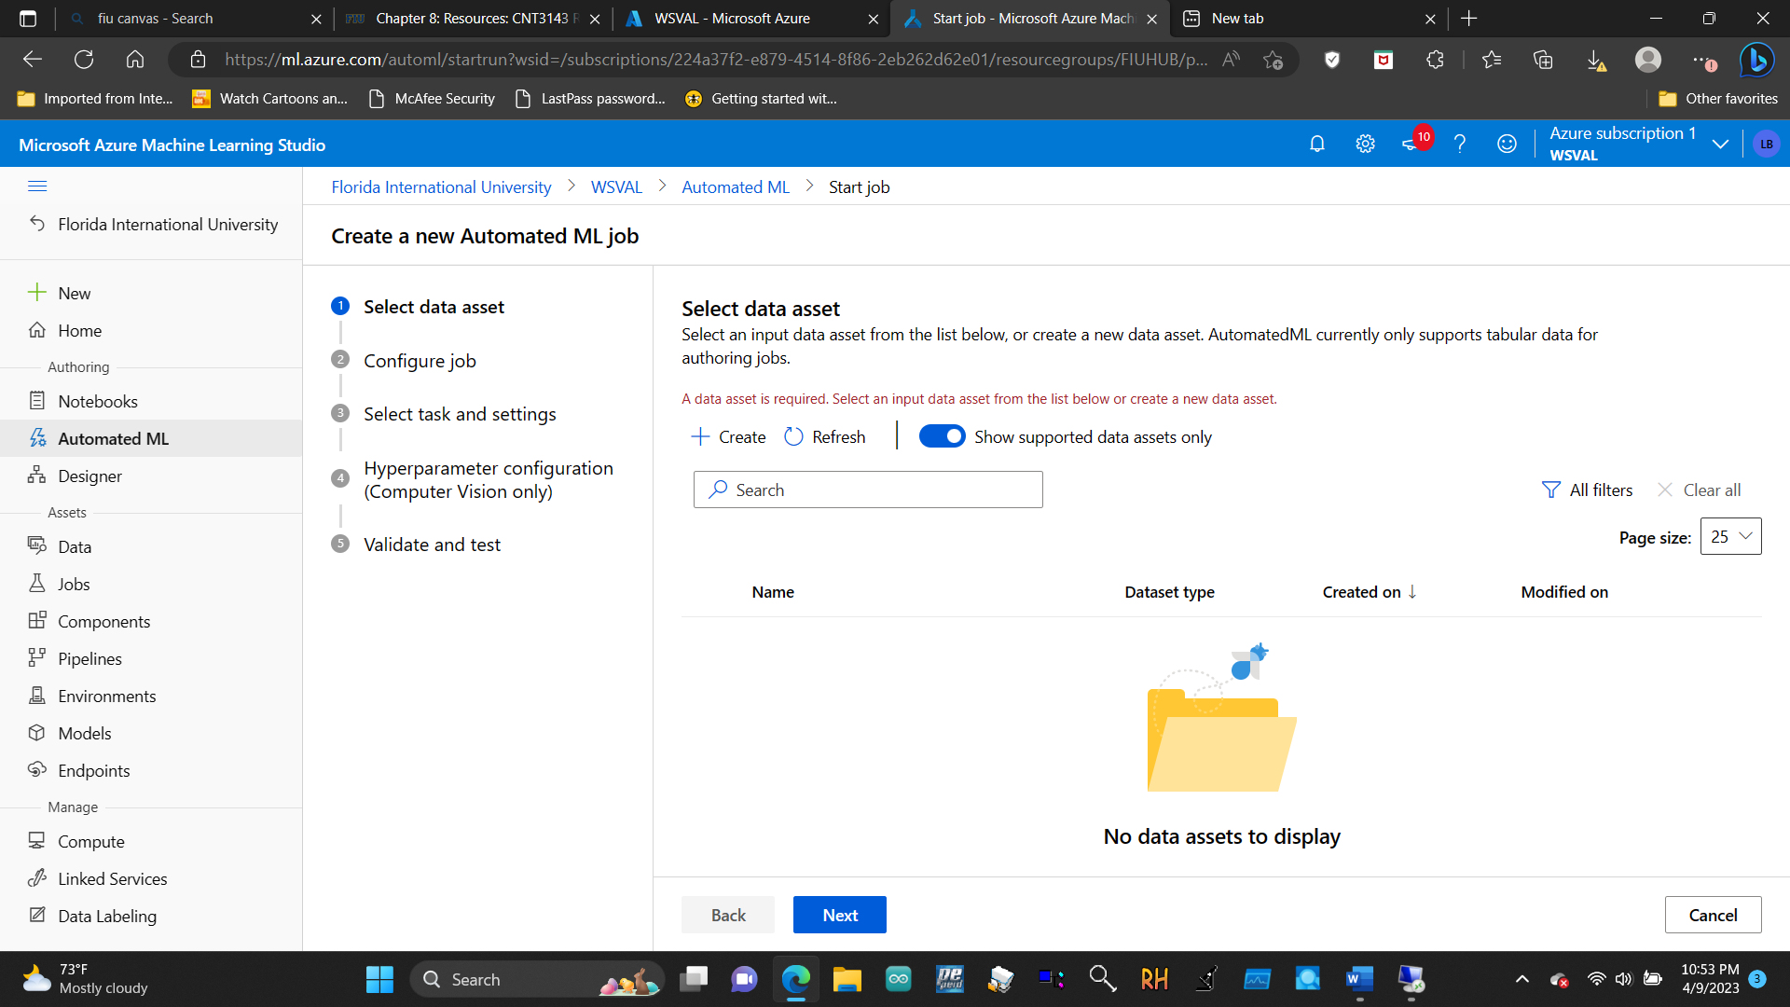

8.1.3 Create and load dataset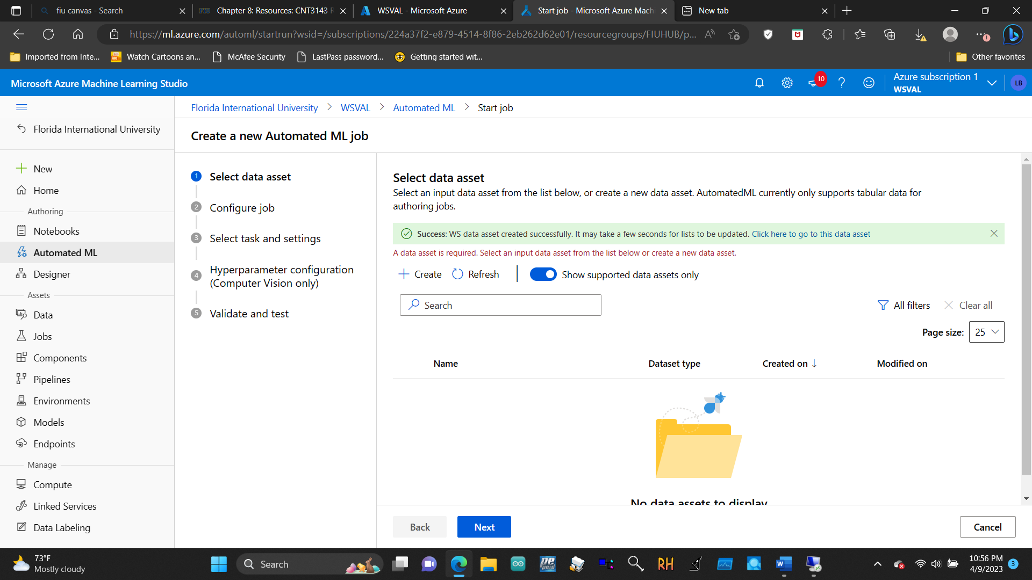

8.1.4 Configure experiment run

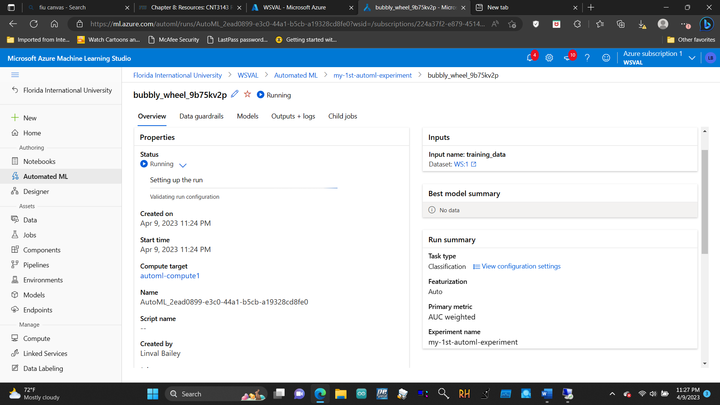

 8.1.5 Explore models

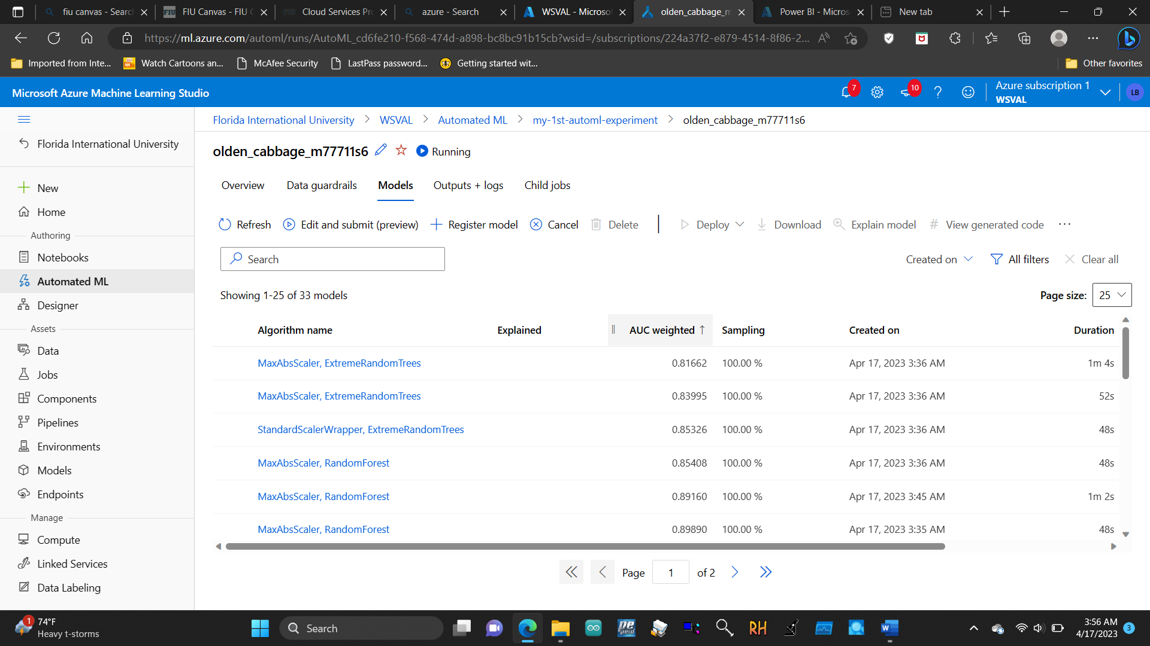

8.1.6 Deploy a model

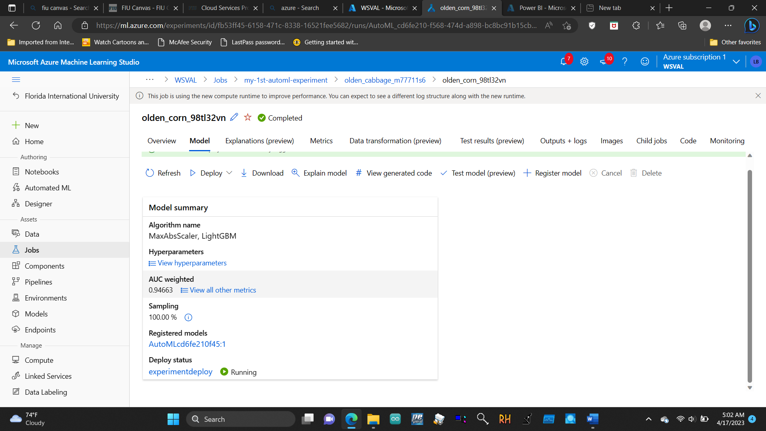

9.1.1 Add a consumer group to your IoT hub

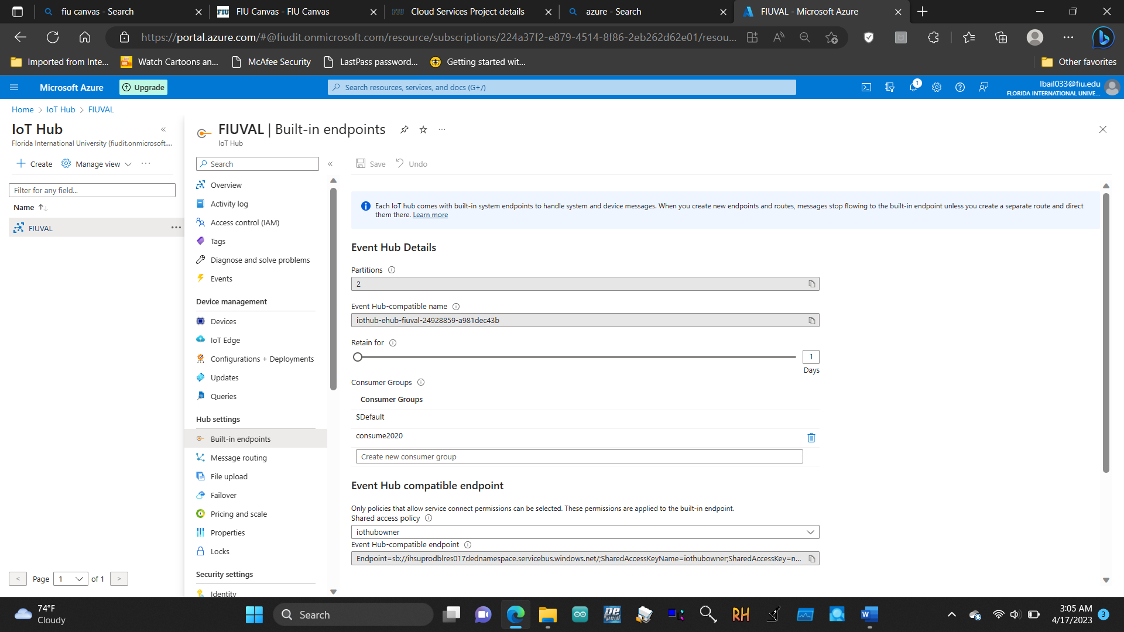

9.1.2 Create a Stream Analytics job

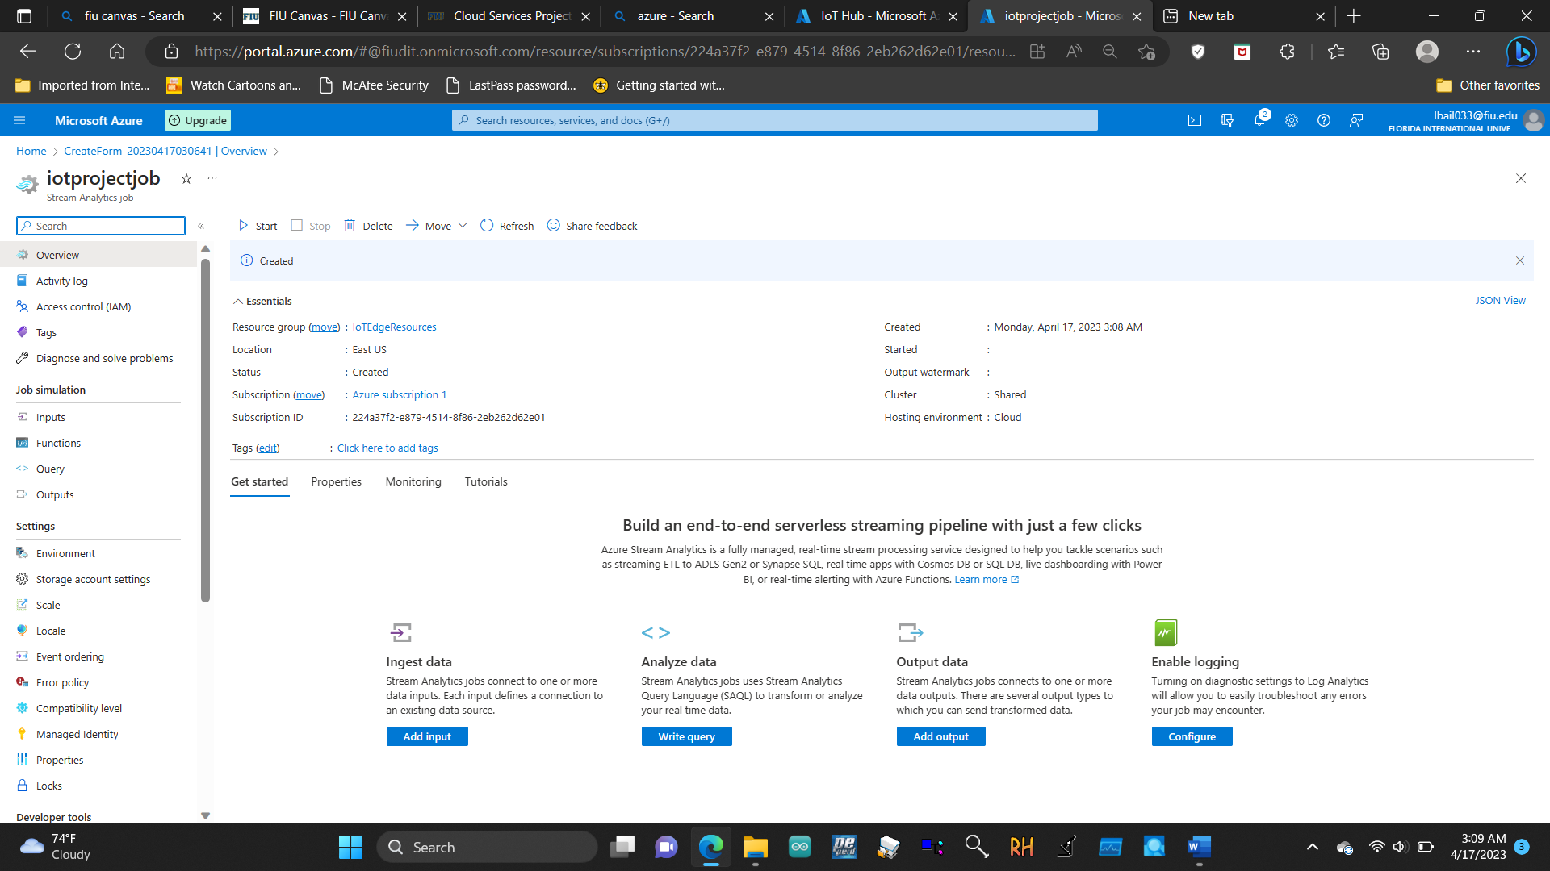

9.1.3 Add an input to the Stream Analytics job

